Happy Xmas-war-is-over John Lennon key A

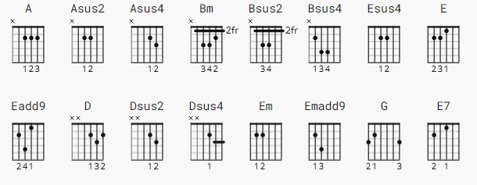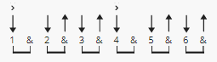
147 bpm

[Verse 1]

A Asus2 Asus4
So this is Christmas
A Bm Bsus2 Bsus4
And what have you done
Bm Esus4 E Eadd9
Another year over
E A Asus2 Asus4
And a new one just begun
A D Dsus2 Dsus4
And so this is Christmas
D Em Emadd9 Esus4
I hope you have fun
Em Asus4 A Asus2
The near and the dear ones
A D Dsus2 Dsus4
The old and the young

[Chorus]

D G
A very merry Christmas
A
And a happy New Year
Em G
Let's hope it's a good one
D E7
Without any fear

[Verse 2]

A Asus2 Asus4
And so this is Christmas
A Bm Bsus2 Bsus4
For weak and for strong
Bm Esus4 E Eadd9
The rich and the poor ones
E A Asus2 Asus4
The road is so long
A D Dsus2 Dsus4
And so happy Christmas
D Em Emadd9 Esus4
For black and for white
Em Asus4 A Asus2
For yellow and red ones
A D Dsus2 Dsus4 D
Let's stop all the fight

[Chorus]

D G
A very merry Christmas
A
And a happy New Year
Em G
Let's hope it's a good one
D E7
Without any fear

[Verse 3]

A Asus2 Asus4
And so this is Christmas
A Bm Bsus2 Bsus4
And what have we done
Bm Esus4 E Eadd9
Another year over
E A Asus2 Asus4
A new one just begun
A D Dsus2 Dsus4
And so happy Christmas
D Em Emadd9 Esus4
We hope you have fun
Em Asus4 A Asus2
The near and the dear ones
A D Dsus2 Dsus4
The old and the young

[Chorus]
D G
A very merry Christmas
A
And a happy New Year
Em G
Let's hope it's a good one
D E7
Without any fear

[Outro]
A Asus2 Asus4 A
War is o - ver
Bm Bsus2 Bsus4 Bm
If you want it
Esus4 E Eadd9 E
War is o - ver
A Asus2 Asus4 A
Now.........................

