Harvest Moon Neil Young key G

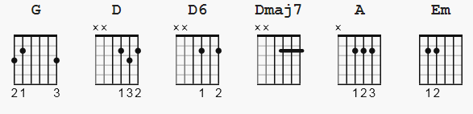 DuxuDuxuDuxuDux 120 bpm
D Du UDU ( old faithful )

( note as of this date 9-2024, the previous strum pattern SHOWN was
6 count and incorrect; should be sync'd 4 or 8 count )

NOTE: compared to my other versions, this substitutes G for Em,
but the endings are still all D chord variants such as D,
D6, Dmaj7 and includes a different suggested strum pattern
from the Em7 version. I include the harmonics at the end.

[Verse]

G
Come a little bit closer
D D6 Dmaj7
Hear what I have to say
G
Just like children sleeping
D D6 Dmaj7
We could dream this night away.
G
But there's a full moon rising
D D6 Dmaj7
Let's go dancing in the light
G
We know where the music's playing
D D6 Dmaj7
Let's go out and feel the night.

[Chorus]

G A
Because I'm still in love with you
Em
I want to see you dance again
G A
Because I'm still in love with you
D D6 Dmaj7
On this harvest moon.

[Verse]

G
When we were strangers
D D6 Dmaj7
I watched you from afar
G
When we were lovers
D D6 Dmaj7
I loved you with all my heart.

G
But now it's getting late
D D6 Dmaj7
And the moon is climbing high
G
I want to celebrate
D D6 Dmaj7
See it shining in your eye.

[Chorus]

G A
Because I'm still in love with you
Em
I want to see you dance again
G A
Because I'm still in love with you
D D6 Dmaj7
On this harvest moon.
G A
Because I'm still in love with you
Em
I want to see you dance again
G A
Because I'm still in love with you
D D6 Dmaj7
On this harvest moon.

END Song chording

----------------

Harmonics part (can be done with the Em7) Half of the verses and then follow chords for the rest of verse

1 + 2 + 3 + 4 +

E h12-----------------|
B |---h12-------------|
G |-------h12---------|
D |---------h12-------|
A |-----------h07-----|
D |-------------------|

NOTE: I think the D sequence sounds better as Dmaj7 D6 D

