Harvest Moon Neil Young key Em ( intermediate ) ( print LANDSCAPE )

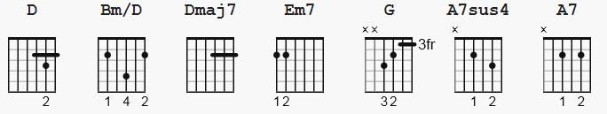

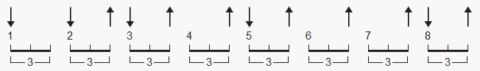 112 bpm suggested pattern

downtune E > D ( only Em7 * requires * use of string 6 )

playing chart pages 2-3 ( without chord grids, or strum pattern )

[CHORDS]
D 0-0-0-11-10-0 or 0-0-0-7-7-5
Bm/D 0-0-0-11-12-0 or 0-0-0-7-7-7
Dmaj7 0-0-0-11-10-9 or 0-0-0-7-7-9
Em7 2-2-0-0-0-0
G 3-x-0-0-0-3
A7sus4 x-0-2-0-3-0
A7 x-0-2-0-2-0

During the first two lines of each verse, the Riff can be played around the D chord
(first position):
D 0-0-0-2-3-2
Bm/D 0-0-0-4-3-2 [Harmonics]
Dmaj7 0-0-0-2-2-2 Em7 x-7-x-12-12-12

[Example riffs in verses]
e|---------------------------9--9--9--9--9--9--| or e|-------5-7-7-7-7-------9--9--9--9--9--9---|
B|-----10-12--12-12-12-------10-10-10-10-10-10-| B|-------7-7-7-7-7-------10-10-10-10-10-10--|
G|-----11-11--11-11-11-------11-11-11-11-11-11-| G|-------7-7-7-7-7-------11-11-11-11-11-11--|
D|-0---12-12--12-12-12----0--------------------| D|-0-------------------0--------------------|
A|---------------------------------------------| A|------------------------------------------|
D|---------------------------------------------| D|------------------------------------------|
Harvest Moon Neil Young key Em ( intermediate )

[Intro Riff]
| D Bm/D | Dmaj7 | D Bm/D | Dmaj7 |
| D Bm/D | Dmaj7 | D Bm/D | Dmaj7 |

[Verse 1]
Em7 D
Come a little bit closer, hear what I have to say
Em7 D
Just like children sleepin’, we could dream this night away
G | D Bm/D | Dmaj7 | D Bm/D | Dmaj7 |
But there’s a full moon risin’, let’s go dancin’ in the light
G | D Bm/D | Dmaj7 | D Bm/D | Dmaj7 |
We know where the music’s playin’, let’s go out and feel the night

[Chorus]
A7sus4 A7
Because I’m still in love with you, I want to see you dance again
A7sus4 A7
Because I’m still in love with you, on this harvest moon

| D Bm/D | Dmaj7 | D Bm/D | Dmaj7 |
| D Bm/D | Dmaj7 | D Bm/D | Dmaj7 |

[Verse 2]
Em7 D
When we were strangers, I watched you from afar
Em7 D
When we were lovers, I loved you with all my heart
G | D Bm/D | Dmaj7 | D Bm/D | Dmaj7 |
But now it’s gettin’ late and the moon is climbin’ high
G | D Bm/D | Dmaj7 | D Bm/D | Dmaj7 |
I want to celebrate, see it shinin’ in your eye

[Chorus]
A7sus4 A7
Because I’m still in love with you, I want to see you dance again
A7sus4 A7
Because I’m still in love with you, on this harvest moon

| D Bm/D | Dmaj7 | D Bm/D | Dmaj7 |
| D Bm/D | Dmaj7 | D Bm/D | Dmaj7 |

[Solo]
| Em7 | % | % | % |
| D | % | % | % |
| Em7 | % | % | % |
| D Bm/D | Dmaj7 | D Bm/D | Dmaj7 |

[Chorus]
A7sus4 A7
Because I’m still in love with you, I want to see you dance again
A7sus4 A7
Because I’m still in love with you, on this harvest moon

[Outro]
| D Bm/D | Dmaj7 | D Bm/D | Dmaj7 |
| D Bm/D | Dmaj7 | D Bm/D | Dmaj7 | D

