Harvest Moon Neil Young key Em7 ( portr-intermediate )

downtune E > D ( only Em7 * requires * use of string 6 )

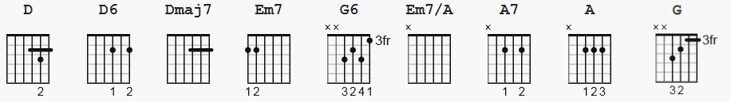

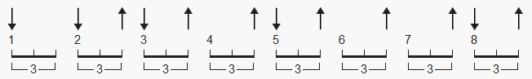 112 bpm suggested pattern

playing chart pages 2-3 ( without chord grids, or strum pattern )

[Example riffs in verses]
e|---------------------------9--9--9--9--9--9--|
B|-----10-12--12-12-12-------10-10-10-10-10-10-|
G|-----11-11--11-11-11-------11-11-11-11-11-11-|
D|-0---12-12--12-12-12----0--------------------|
A|---------------------------------------------|
D|---------------------------------------------|

OR

e|-------5-7-7-7-7-------9--9--9--9--9--9---|
B|-------7-7-7-7-7-------10-10-10-10-10-10--|
G|-------7-7-7-7-7-------11-11-11-11-11-11--|
D|-0-------------------0--------------------|
A|------------------------------------------|
D|------------------------------------------|

NOTE:

G6 looks a lot like a Cmaj7
If you don't downtune, Em7 looks like 020000
Be sure not to strum string 6 for D, D6, Dmaj7
Harvest Moon Neil Young ( intermediate )

[Intro]

Another way to do the intro riff

| D D6 | Dmaj7 | D D6 | Dmaj7 |
| D D6 | Dmaj7 | D D6 | Dmaj7 |

[Intro] ??

[Verse 1]

Em7
Come a little bit closer
| D D6 | Dmaj7 | D D6 | Dmaj7 |
Hear what I have to say
Em7
Just like children sleepin'
| D D6 | Dmaj7 | D D6 | Dmaj7 |
We could dream this night away

G6
But there's a full moon risin'
| D D6 | Dmaj7 | D D6 | Dmaj7 |
Let's go dancin' in the light
G6
We know where the music's playin'
| D D6 | Dmaj7 | D D6 | Dmaj7 |
Let's go out and feel the night

[Chorus]

Em7/A A7
Because I'm still in love with you
Em7/A
I want to see you dance again
A
Because I'm still in love with you
[ D ]
On this harvest moon

| D D6 | Dmaj7 | D D6 | Dmaj7 |
| D D6 | Dmaj7 | D D6 | Dmaj7 |

[Verse 2]

Em7
When we were strangers
| D D6 | Dmaj7 | D D6 | Dmaj7 |
I watched you from afar
Em7
When we were lovers
| D D6 | Dmaj7 | D D6 | Dmaj7 |
I loved you with all my heart

G6
But now it's gettin late
| D D6 | Dmaj7 | D D6 | Dmaj7 |
And the moon is climbin' high
G6
I want to celebrate
| D D6 | Dmaj7 | D D6 | Dmaj7 |
See it shinin' in your eye

[Chorus]

Em7/A A7
Because I'm still in love with you
Em7/A
I want to see you dance again
A
Because I'm still in love with you

On this harvest

| D D6 | Dmaj7 | D D6 | Dmaj7 |
moon
| D D6 | Dmaj7 | D D6 | Dmaj7 |

[Solo]

| G | % | % | % |
| D D6 | Dmaj7 | D D6 | Dmaj7 |
| G | % | % | % |
| D D6 | Dmaj7 | D D6 | Dmaj7 |
[Chorus]

Em7/A A7
Because I'm still in love with you
Em7/A
I want to see you dance again
A
Because I'm still in love with you

On this harvest

[Outro]

| D D6 | Dmaj7 | D D6 | Dmaj7 |
moon
| D D6 | Dmaj7 | D D6 | Dmaj7 |

