Hey Jude The Beatles key F

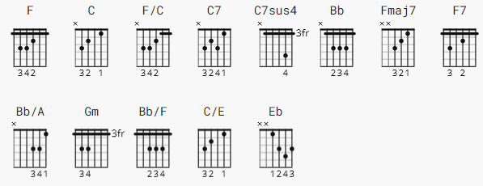 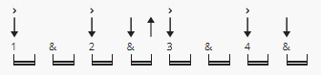 75bpm

also: B D B D B D . . .
[Verse 1]
F C
Hey Jude, don't make it bad
F/C C7 C7sus4 C7 F
Take a sad song and make it better
Bb F
Remember to let her into your heart
C F
and then you can start to make it better

[Verse 2]
F C
Hey Jude, don't be afraid
F/C C7 C7sus4 C7 F
You were made to go out and get her
Bb F
The minute you let her under your skin
C F Fmaj7 F7
then you begin to make it better

[Chorus]
Bb Bb/A Gm
And anytime you feel the pain, hey Jude, refrain
Bb/F C/E C F Fmaj7 F7
Don't carry the world upon your shoulders
Bb Bb/A Gm
For well you know that it's a fool who plays it cool
Bb/F C/E C F
by making his world a little colder

[Interlude]
F F7 C C7 C F C7
Na na na na na na na na naa

[Verse 3]
F C
Hey Jude, don't let me down
F/C C7 C7sus4 C7 F
You have found her, now go and get her
Bb F
Remember to let her into you heart
C F Fmaj7 F7
then you can start to make it better

[Chorus]
Bb Bb/A Gm
So let it out and let it in, hey Jude, begin
Bb/F C/E C F Fmaj7 F7
You're waiting for someone to perform with
Bb Bb/A Gm
And don't you know that it's just you, hey Jude, you'll do
Bb/F C/E C F
The movement you need is on your shoulders

[Interlude]
F F7 C C7 C F C7
Na na na na na na na na naa yeah

[Verse 4]
F C
Hey Jude, don't make it bad
F/C C7 C7sus4 C7 F
Take a sad song and make it better
Bb F
Remember to let her under your skin
C F
and then you'll begin to make it better, better, better, better, better, better, ahhhhhh!

[Outro]
F Eb
Na na na na na na na
Bb
Na na na na
F
Hey Jude

F Eb
Na na na na na na na
Bb
Na na na na
F
Hey Jude

(Repeat and fade)

--------------------
similar to Marty tutorial in key F
https://www.youtube.com/watch?v=uf7WjYN73AM

