Home On The Range Gene Autry key D

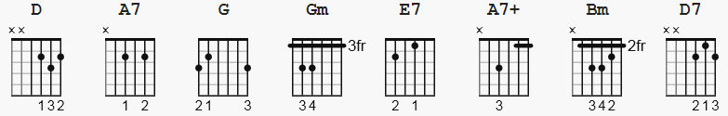 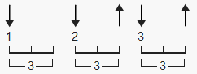 100 bpm

[Intro] Capo 1, key Eb Gm = 310033
D A7 D D

[Verse 1]
D G Gm
Oh give me a home where the buffalo roam,
D E7 A7 A7+
Where the deer and the antelope play.
D G Gm
Where seldom is heard a discouraging word,
D A7 D
And the skies are not cloudy all day.

[Chorus]
A7 D
Home, home on the range,
D Bm E7 A7 A7+
Where the deer and the antelope play.
D G Gm
Where seldom is heard a discouraging word,
D A7 D
And the skies are not cloudy all day.

[Verse 2]
D G Gm
How often at night when the heavens are bright,
D E7 A7 A7+
With the light from the glittering stars,
D D7 G Gm
Have I stood there amazed and asked as I gazed,
D A7 D
If their glory exceeds that of ours.

[Chorus] (11 pt font)
A7 D
Home, home on the range,
D Bm E7 A7 A7+
Where the deer and the antelope play.
D G Gm
Where seldom is heard a discouraging word,
D A7 D
And the skies are not cloudy all day.

A7 D
Home, home on the range,
D Bm E7 A7 A7+
Where the deer and the antelope play.
D G Gm
Where seldom is heard a discouraging word,
D A7 D
And the skies are not cloudy all day.

