Honky Tonk Women The Rolling Stones key G

chords: A C D G

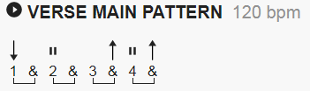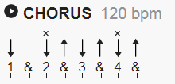

[Intro]

G G G G

[Verse 1]

G C
I met a gin-soaked barroom queen in Memphis
G A D
She tried to take me upstairs for a ride
G C
She had to heave me right across her shoulder
G D G
‘cause I just can't seem to drink you off my mind

[Chorus]

G D G
It's the ho-oooo-nky tonk women
G D G
That gimme, gimme, gimme the honky-tonk blues

[Verse 2]

G C
I laid a divorcee in New York City
G A D
I had to put up some kind of a fight
G C
The lady then she covered me in roses
G D G
She blew my nose and then she blew my mind

[Chorus]

G D G
It's the ho-oooo-nky tonk women
G D G
That gimme, gimme, gimme the honky-tonk blues
[Solo]

| G | G | C | C |
| G | A | D | D |
| G | G | C | C |
| G | D | G | G |

[Chorus]

G D G
It's the ho-oooo-nky tonk women
G D G
That gimme, gimme, gimme the honky-tonk blues

G D G
It's the ho-oooo-nky tonk women
G D G
That gimme, gimme, gimme the honky-tonk blues

[no outro yet]

