Horse With No Name America key Em

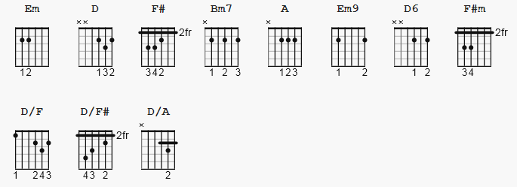

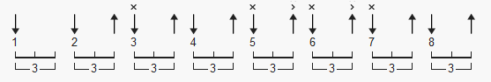 123 bpm

(former comment): I kno this is 100% correct bescuz its out of a song book

Chords used:

Em D\F# Bm7 D\A
E --0-- --2-- --X-- --X--
A --2-- --0-- --2-- --0--
D --2-- --0-- --4-- --0--
G --0-- --2-- --2-- --2--
B --0-- --3-- --3-- --3--
e --0-- --2-- --2-- --2--

Em9 D6\9\F# A F#m
E --0-- --2-- --X-- --2--
A --2-- --0-- --0-- --4--
D --2-- --0-- --2-- --4--
G --0-- --2-- --2-- --2--
B --3-- --0-- --2-- --2--
e --2-- --0-- --0-- --2--

Horse With No Name America key Em

[Intro:] Em |D/F |Em |D/F#

[Verse 1:] Em D/F# Em D/F#
On the first part of the journey, I was looking at all the life.
Em D/F#
There were plants and birds and rocks and things,
Em D/F#
There was sand and hills and rings.
Em D/F# Bm7
The first thing i met was a fly with a buzz
Em D/F# Bm7
And the sky with no clouds.
Em D/F# Bm7
The heat was hot and the ground was dry,
Em D/F# D/A
But the air was full of sound.

[Chorus:] Em9 D6/9/F#
I've been through the desert on a horse with no name,
Em9 D6/9/F#
It felt good to be out of the rain.
Em9 D6/9/F#
In the desert you can't remember your name
Em9 D6/9/F#
'Cause there ain't no one for to give you no pain.

[Link 1:] |:Em9 D6/9/F# Em9 D6/9/F# :|
La la, la la la la la, la la la, la la.

[Verse 2:] Em D/F# Em D/F#
After two days in the desert sun, my skin began to turn red
Em D/F#
After three days in the desert fun,
Em D/A
I was looking at a river bed.
Em D/F#
And the story it told of a river that flowed
Em D/F# D/A
Made me sad to think it was dead.

[Chorus:] Em9 D6/9/F#
I've been through the desert on a horse with no name,
Em9 D6/9/F#
It felt good to be out of the rain.
Em9 D6/9/F#
In the desert you can't remember your name
Em9 D6/9/F#
'Cause there ain't no one for to give you no pain.

[Link 2:] Em9 D6/9/F# Em9 D6/9/F#
La la, la la la la la, la la la, la la.
Em9 D6/9/F# Em9 A
La la, la la la la la, la la la, la la.

[solo:] Em |F#m |Em9 |A |
Em9 |D6/9/F# Bm7 |Em |

[Verse 3:] A Em9 D6/9/F#
After nine days I let the horse run free
Em9 D6/9/F# Bm7
’Cause the desert had turned to sea
Em9 D6/9/F# Bm7
There were plants and birds and rocks and things
Em9 D6/9/F# Bm7
There was sand and hills and rings
Em9 D6/9/F#
The ocean is a desert with it’s life underground
Em9 D6/9/F#
And a perfect disguise above
Em9 D6/9/F#
Under the cities lies a heart made of ground
Em9 D/A
But the humans will give no love

[Chorus:] Em9 D6/9/F#
I've been through the desert on a horse with no name,
Em9 D6/9/F#
It felt good to be out of the rain.
Em9 D6/9/F#
In the desert you can't remember your name
Em9 D6/9/F#
'Cause there ain't no one for to give you no pain.

[Coda:] |:Em9 D6/9/F# Em9 D6/9/F# :|
La la, la la la la la, la la la, la la.

