Hotel California Eagles key Bm ( finger Am )

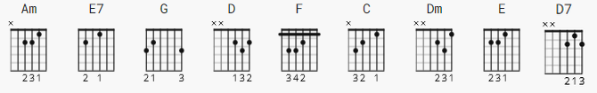

CAPO 2

strum #1
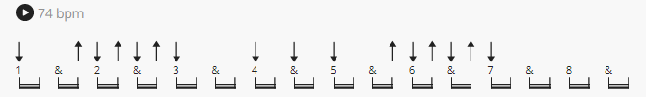

strum #2
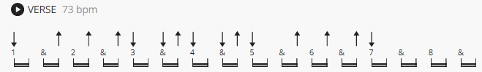

strum #3
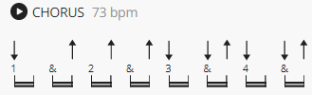

* = Play softer chords or individual strings like intro.
** = Hard strums getting back into final verse.

[Intro] (х2)

Am E7 G D
e|-0---------------|-0---------------|-3-------3-------|-2-------2-------|
B|-1-------1-------|-0-------0-------|-0-----0---0-----|-3-----3---3-----|
G|-2-----2---2-----|-1-----1---1-----|-0---0-------0---|-2---2-------2---|
D|-2---2-------2---|-0---0-------0---|-0-------------0-|-0-------------0-|
A|-0-------------0-|-2-------------2-|-2---------------|-----------------|
E|-----------------|-0---------------|-3---------------|-----------------|

F C Dm E
e|-1-------1-------|-0-------0-------|-1---------------|-0---------------|
B|-1-----1---1-----|-1-----1---1-----|-3-------3-------|-0-------1-------|
G|-2---2-------2---|-0---0-------0---|-2-----2---2-----|-1-----1---1-----|
D|-3-------------3-|-2-------------2-|-0---0-------0---|-2---2-------2---|
A|-3---------------|-3---------------|---------------0-|-2-------------2-|
E|-----------------|-----------------|-----------------|-0---------------|
Hotel California Eagles key Bm ( finger Am )

[Verse 1]

Am E7
On a dark desert highway, cool wind in my hair
G D
Warm smell of colitas rising up through the air
F C
Up ahead in the distance, I saw a shimmering light
Dm
My head grew heavy and my sight grew dim,
E
I had to stop for the night

[Verse 2]

Am E7
There she stood in the doorway, I heard the mission bell
G
And I was thinking to myself
D
This could be heaven or this could be hell
F C
Then she lit up a candle, and she showed me the way
Dm
There were voices down the corridor,
E7
I thought I heard them say...

[Chorus]

F C
Welcome to the Hotel California
E7 Am
Such a lovely place (such a lovely place), such a lovely face
F C
There's plenty of room at the Hotel California
Dm E7
Any time of year, (any time of year) You can find it here...

[Verse 3]

Am E7
Her mind is Tiffany twisted, She got the Mercedes bends
G D
She got a lot of pretty pretty boys that she calls friends
F C
How they danced in the courtyard, sweet summer sweat
Dm E7
Some dance to remember, some dance to forget
[Verse 4]

Am E7
So I called up the captain; "Please bring me my wine" (he said)
G D
"We haven't had that spirit here since 1969"
F C
And still those voices are calling from far away
Dm
Wake you up in the middle of the night
E7
Just to hear them say...

[Chorus]

F C
Welcome to the Hotel California
E7 Am
Such a lovely place (such a lovely place), such a lovely face
F C
They're livin' it up at the Hotel California
Dm E7
What a nice surprise (what a nice surprise), bring your alibis

[Verse 5]

Am* E7*
Mirrors on the ceiling, the pink champagne on ice (and she said)
G* D*
We are all just prisoners here, of our own device
F* C*
And in the master's chambers, they gathered for the feast
Dm*
They stab it with their steely knives, but they
E7**
Just can't kill the beast

[Verse 6]

Am E7
Last thing I remember, I was running for the door
G D
I had to find the passage back to the place I was before
F C
"Relax" said the night man, "we are programmed to receive,
Dm
You can check out any time you like
E7
But you can never leave"

[Outro] Am E7 G D7 F C Dm E7 (x5)

