I Get Around Beach Boys key G

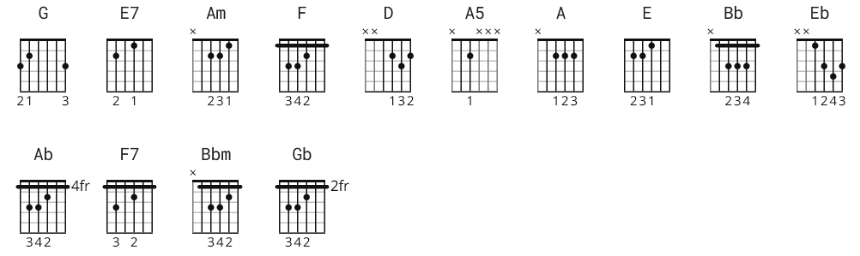

NOTE: the lyric order follows the video (I think ), however,
the chords, off by 5,from sheets some +/- 1 fret - could use a little work.; best sound is playing top 3 strings!!

G E7
Round, round, get around, I get around
Am F D
Yeah, get around, round, round, I get around

G
I get around (get around, round, round, I get around)
E7
From town to town (get around, round, round, I get around)
Am
I'm a real cool head (get around, round, round, I get around)
F D
I'm makin' real good bread (get around, round, round, I get around)

A5 D A5 D
I'm gettin' bugged drivin' up and down the same old strip
A5 D A5 D
I gotta find a new place where the kids are hip

G

A5 D A5 D
My buddies and me are gettin' real well known
A5 D A5 D
Yeah, the bad guys know us and they leave us alone

G
I get around (get around, round, round, I get around)
E7
From town to town (get around, round, round, I get around)
Am
I'm a real cool head get around, round, round, I get around)
F D
I'm makin' real good bread (get around, round, round, I get around)
E7 A
I get around, round, get around, round, wah-ooo
D A5 E F
Wah wah-ooo, wah wah-ooo, wah wah-oooooo

Bb Eb Bb Eb
We always take my car 'cause it's never been beat
Bb Eb Bb Eb
And we've never missed yet with the girls we meet

Ab

Bb Eb Bb Eb
None of the guys go steady 'cause it wouldn't be right
Bb Eb Bb Eb
To leave your best girl home now on Saturday night

Ab
I get around (get around, round, round, I get around)
F7
From town to town (get around, round, round, I get around)
Bbm
I'm a real cool head get around, round, round, I get around)
Gb Eb
I'm makin' real good bread (get around, round, round, I get around)

F7 Eb
I get around, round, rou-ou-ou-ou-ou-ou-ou-ound

Ab F7
Round, round, get around, I get around
Bbm Gb Eb
Yeah, get around, round, round, I get around

Ab
Get around, round, round, I get around
F7
Get around, round, round, I get around
Bbm
Get around, round, round, I get around)
Gb Eb
Get around, round, round, I get around)

Ab
Get around, round, round, I get around
F7
Get around, round, round, I get around
Bbm
Get around, round, round, I get around)
Gb Eb
Get around, round, round, I get around)

