I Walk The Line Johnny Cash keys E7-B7

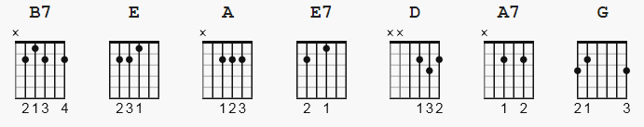 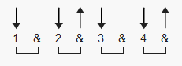 212 bpm

on a popular version, capo 1 is needed.

[Intro]

e|-------|-----------------|-----------------|-----------------|
B|-------|-----------------|-----------------|-----------------|
G|-------|-----------------|-----------------|-----------------|
D|-------|-----------------|-0-------0-0-----|-----2-----------|
A|-------|-0-------0-0-2-4-|-----0-------4-2-|-0-------0-0-----|
E|-0-2-4-|-----0-----------|-----------------|-------------4-2-|

e|-----------------|-----------------|----------------- |
B|-----------------|-----------------|----------------- |
G|-----------------|-----------------|----------------- |
D|-----------------|-----1-----------|----------------- |
A|-----2---2-------|-2-------2-0-----|-----2-------2- play 0-2 12 |
E|-0---------0-2-0-|-------------4-2-|-0-------0----- more times + |

(Either Johnny or his guitarist continues the two-note shuffle while the chords are):

[Verse 1]

B7 E
I keep a close watch on this heart of mine
B7 E
I keep my eyes wide open all the time
A E
I keep the ends out for the tie that binds
B7 E
Because you're mine, I walk the line

(Then walk up to A)
e|---------|
B|---------|
G|---------|
D|---------|
A|-------0-|
E|-0-2-4---| play 0-2 7 more times
[Verse 2]

E7 A
I find it very, very easy to be true
E7 A
I find myself alone when each day is through
D A
Yes, I'll admit that I'm a fool for you
E7 A
Because you're mine, I walk the line

(Then walk up to D)
e|---------|
B|---------|
G|---------|
D|-------0-|
A|-0-2-4---|
E|---------| play 0-2 7 more times

[Verse 3]

A7 D
As sure as night is dark and day is light
A7 D
I keep you on my mind both day and night
G D
And happiness I've known proves that it's right
A7 D
Because you're mine, I walk the line

(Back down to A)
e|---------|
B|---------|
G|---------|
D|-0-------|
A|---4-2-0-| play 0-2 8 more times
E|---------| - -> possibly include the first 0 in the 0-2 ?

[Verse 4]

E7 A
You've got a way to keep me on your side
E7 A
You give me cause for love that I can't hide
D A
For you I know I'd even try to turn the tide
E7 A
Because you're mine, I walk the line

(And back to E again)
e|---------|
B|---------|
G|---------|
D|---------|
A|-0-------|my recording has a one-count dropout then
E|---4-2-0-| play 0-2 7 more times.

[Verse 5]

B7 E
I keep a close watch on this heart of mine
B7 E
I keep my eyes wide open all the time
A E
I keep the ends out for the tie that binds
B7 E
Because you're mine, I walk the line

[Outro]

e|-----------------------------|
B|-----------------------------|
G|-----------------------------|
D|-----------------------------|
A|-2-------2-------2-------2---|
E|-----0-------0-------0-------|
(fade)

