I Want To Hold Your Hand Beatles key

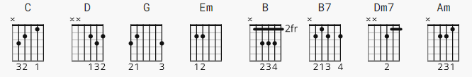

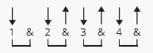 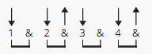 132 bpm
verse chorus

[Intro]
C C D C C D C C D D
(Oh yeah ...)

[Verse 1]
G D
Oh yeah, I'll tell you something
Em Bm
I think you'll understand
G D
When I say that something
Em B7
I wanna hold your hand

[Chorus]
C D G Em
I wanna hold your hand
C D G
I wanna hold your hand

[Verse 2]
G D
Oh please, say to me
Em Bm
You'll let me be your man
G D
And please, say to me
Em B7
You'll let me hold your hand

[Chorus]
C D G Em
Now let me hold your hand
C D G
I wanna hold your hand

[Bridge]
Dm7 G C Am
And when I touch you I feel happy inside
Dm7 G C
It's such a feeling that my love
C C D C C D C C D
I can't hide - I can't hide - I can't hide

[Verse 3]
G D
Yeah, you, got that something
Em Bm
I think you'll understand
G D
When I say that something
Em B7
I wanna hold your hand

[Chorus]
C D G Em
I wanna hold your hand
C D G
I wanna hold your hand

[Bridge]
Dm7 G C Am
And when I touch you I feel happy inside
Dm7 G C
It's such a feeling that my love
C C D C C D C C D
I can't hide - I can't hide - I can't hide

[Verse 4]
G D
Yeah, you got that something,
Em Bm
I think you'll understand
G D
When I feel that something
Em B7
I wanna hold your hand

[Chorus]
C D G Em
I wanna hold your hand
C D B7
I wanna hold your hand
C D C G ( better - barre CCCC G )
I wanna hold your ha--and

END

