I'm So Lonesome I Could Cry Hank Williams 1949 *

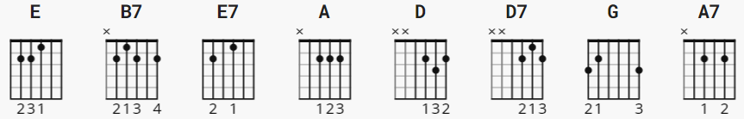

Strumming for 3/4 time
D D Du or B D Du ; 1 2 3&

[INTRO]

E B7 E
Capo II

E = D
E7 = D7
A = G
B7 = A7

E E7 E
Hear the lonesome whippoorwill
E7
He sounds too blue to fly
A E
The midnight train is whining low
B7 E
I'm So Lonesome I Could Cry

E E7 E
I never seen a night so long
E7
When times goes crawling by
A E
The moon just went behind a cloud
B7 E E7
To hide it's face and cry

E E7 A E B7 E E7

E E7 E
Did you ever see a robin weep
E7
When leaves began to die?
A E
Like me he's lost the will to live
B7 E E7
I'm so lonesome I could cry

E E7 A E B7 E E7

E E7 E
The silence of a falling star
E7
Lights up a purple sky
A E
And as I wonder where you are
B7 E
I'm so lonesome I could cry

[NO OUTRO]

