I'm So Lonesome I Could Cry Hank Williams 1949 *

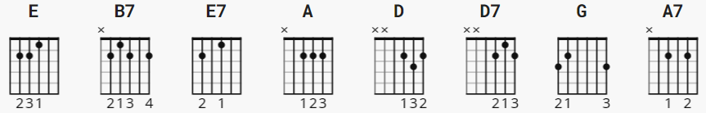

signature is 3/4
Suggested basic strum: D D Du or B D Du ; 1 2 3&

[INTRO]

E B7 E

E E7 E
Hear the lonesome whippoorwill
E E7
He sounds too blue to fly
A Am E C#m
The midnight train is whining low
E B7 E
I'm So Lonesome I Could Cry

E E7 E
I never seen a night so long
E E E7
When times goes crawling by
A Am E C#m
The moon just went behind a cloud
E B7 E
To hide it's face and cry

E E7 A E B7 E E7

E E7 E
Did you ever see a robin weep
E E7
When leaves began to die?
A Am E C#m
Like me he's lost the will to live
E B7 E E7
I'm so lonesome I could cry

E E7 A E B7 E E7

E E7 E
The silence of a falling star
E E E7
Lights up a purple sky
A Am E C#m
And as I wonder where you are
E B7 E--------C#m
I'm so lonesome I could cry

[OUTRO]

E B7 E
I'm so lonesome I could cry

* Alternate:

Capo II

E = D
E7 = D7
A = G
B7 = A7
C#m = Bm

