If Bread (Intermediate) key A see arpeggio style videos

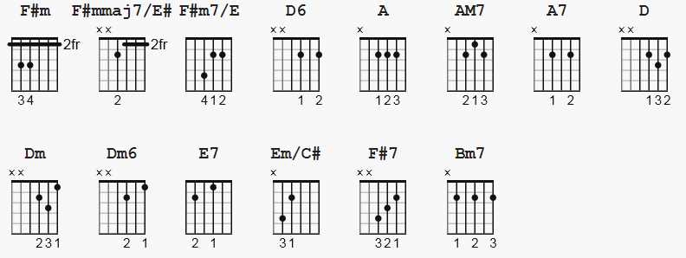

F#m xx4222 Bm7 x13121
F#mmaj7/E# xx3222 AM7 5x775x (barre)
F#m7/E xx2222 Dm6 xx7767 (barre)
D6 xx0202

[Intro]

A AM7 A7 D Dm A Dm6 E7

[Verse 1]

A AM7 A7 D
If a picture paints a thousand words then why can't I paint you?
Dm A Dm6 E7
The words will never show the you I've come to know
A AM7 A7 D
If a face could launch a thousand ships then where am I to go?
Dm A Dm6 E7
There's no one home but you, you're all that's left me to

[Chorus]

F#m F#mmaj7/E# F#m7/E D6
And when my love for life is running dry
Em/C# F#7 Bm7 E7
You come and pour yourself on me

[Verse 2]

A AM7 A7 D
If a man could be two places at one time I'd be with you
Dm A Dm6 E7
Tomorrow and today beside you all the way
A AM7 A7 D
If the world should stop revolving, spinning slowly down to die
Dm A Dm6 E7
I'd spend the end with you and when the world was through

[Chorus]

F#m F#mmaj7/E# F#m7/E D6
Then one by one the stars would all go out
Em/C# F#7 Bm7 E7 A D Dm6 A
Then you and I would simply fly away...

--------------------
Notes:
One basic for learning to pick the notes is 8 picks:
string: 42312312 with simple variations for bass pick:
52312312 and 62312312

