If Bread key Aadd9

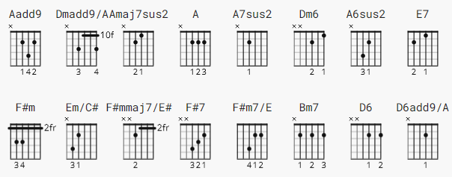

Aadd9 x07600 Dmadd9/A x03230
Amaj7sus2 x06400 A x02220
A7sus2 x05400 Dm6 xx0201
A6sus2 x04200 E7 0x2130

F#m xx4222 Em/C# x4x000
F#mmaj7/E# xx3222 F#7 242322
F#m7/E xx2222 Bm7 x24232
D6 xx0202 D6add9/A x04430

[Intro]

Aadd9 Amaj7sus2 A7sus2 A6sus2
Dmadd9/A A Dm6 E7

[Verse 1]

Aadd9 Amaj7sus2 A7sus2 A6sus2
If a picture paints a thousand words then why can't I paint you?
Dmadd9/A A Dm6 E7
The words will never show the you I've come to know
Aadd9 Amaj7sus2 A7sus2 A6sus2
If a face could launch a thousand ships then where am I to go?
Dmadd9/A A Dm6 E7
There's no one home but you, you're all that's left me to

[Chorus]

F#m F#mmaj7/E# F#m7/E D6
And when my love for life is running dry
Em/C# F#7 Bm7 E7
You come and pour yourself on me

[Verse 2]

Aadd9 Amaj7sus2 A7sus2 A6sus2
If a man could be two places at one time I'd be with you
Dmadd9/A A Dm6 E7
Tomorrow and today, beside you all the way
Aadd9 Amaj7sus2 A7sus2 A6sus2
If the world should stop revolving, spinning slowly down to die
Dmadd9/A A Dm6 E7
I'd spend the end with you and when the world was through

[Chorus]

F#m F#mmaj7/E# F#m7/E D6
Then one by one the stars would all go out
Em/C# F#7 Bm7 E7 Aadd9 D6add9/A Dmadd9/A A
Then you and I would simply fly away...

