If I Had A Hammer Peter Paul and Mary

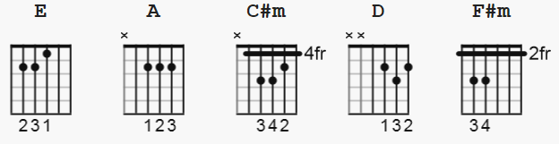

Paul plays using all open chords, other than the C#m
For the purpose of singing along, I prefer to play all chords as barre chords, other than the
open E which is noted as E * but this tab may also be used to play as Paul does.
(begin singing on E chord of Intro)

General Strum Pattern:
A C#m D E
dud dud du uud (d=down u=up)

[Intro]
A C#m D E x2

[Verse 1]
A C#m D
If I had a hammer,
E A C#m D
I'd hammer in the morning,
E A C#m D
I'd hammer in the evening,
E E *
All over this land,

[Chorus]
A
I'd hammer out danger,
F#m
I'd hammer out a warning,
D A
I'd hammer out love between,
D A
My brothers and my sisters,
D A E A C#m D E
All over this land.

[Instrumental]
A C#m D E

[Verse 2]
A C#m D
If I had a bell,
E A C#m D
I'd ring it in the morning,
E A C#m D
I'd ring it in the evening,
E E *
All over this land,

[Bridge]
A
I'd ring out danger,
F#m
I'd ring out a warning,
D A
I'd ring out love between,
D A
My brothers and my sisters,
D A E A C#m D E
All over this land.

[Instrumental]
A C#m D E

[Verse 3]
A C#m D
If I had a song
E A C#m D
I'd sing it in the morning,
E A C#m D
I'd sing it in the evening,
E E *
All over this land,

[Chorus]
A
I'd sing out danger,
F#m
I'd sing out a warning,
D A
I'd sing out love between,
D A
My brothers and my sisters,
D A E A C#m D E
All over this land.

[Instrumental] ( 11 pt here on )
A C#m D E

[Verse 4]
A C#m D
Well, I've got a hammer
E A C#m D
and I've got a bell
E A C#m D
and I've got a song to sing
E E *
all over this land

[Outro]
A
It's the hammer of justice
F#m
It's the bell of freedom
D A
It's a song about love between my
D A
brothers and my sisters
D A E A D A
all over this land
-END

