If You Could Read My Mind Gordon Lightfoot key G

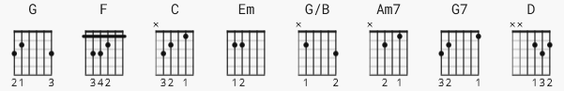 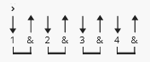 123 bpm

capo 2 NOTE: Lightfoot picks most of the song

[Intro]

G (Repeat Twice) Also play between verses

e|---------------------------------|
B|---------------------------------|
G|-----0-----0---2-----2-----2-4-0-|x2
D|---0-----0---0-----0-----0-------|
A|---------------------------------|
E|-3-----3---------3-----3---------|

[Verse 1]

G
If you could read my mind love
F
What a tale my thoughts could tell
G
Just like an old time movie
F
'bout a ghost from a wishin' well
G G7 C
In a castle dark or a fortress strong
D Em
With chains upon my feet
C G
You know that ghost is me
C G/B
And I will never be set free
Am7 D G
As long as I'm a ghost that you can't see

[Instrumental]
G
[Verse 2]
G
If I could read your mind love
F
What a tale your thoughts could tell
G
Just like a paperback novel
F
The kind that drugstores sell
G G7 C
When you reach the part where the heartaches come
D Em
The hero would be me
C G
But heroes often fail
C G/B
And you won't read that book again
Am7 D G
Because the ending's just too hard to take

[Instrumental]

G F G F

[Verse 3]

G G7 C
I'd walk away like a movie star
D Em
Who gets burned in a three way script
C G
Enter number two
C G/B
A movie queen to play the scene
Am7 D Em
Of bringing all the good things out in me
C G
But for now love, let's be real
C G/B
* I never thought I could act this way *
Am7 D
And I've got to say that I just don't get it
C G/B
I don't know where we went wrong
Am7
But the feelin's gone
D G
And I just can't get it back
[Instrumental]
G

[Verse 4]

G
If you could read my mind love
F
What a tale my thoughts could tell
G
Just like an old time movie
F
'bout a ghost from a wishin' well
G G7 C
In a castle dark or a fortress strong

D Em
With chains upon my feet
C G
But stories always end
C G/B
And if you read between the lines
Am7 D Em
You'll know that I'm just tryin' to understand
C G
The feelin's that you lack
C G/B
I never thought I could feel this way
Am7 D
And I've got to say that I just don't get it
C G/B
I don't know where we went wrong
Am7
But the feelin's gone
D G
And I just can't get it back

[Outro]

F G

