Imagine Beatles key C

PRELIMINARIES: ( hints to print )

Chord grids and strum pattern page 1
chord variations and INTRO TABS page 2
Chords for playing page 3

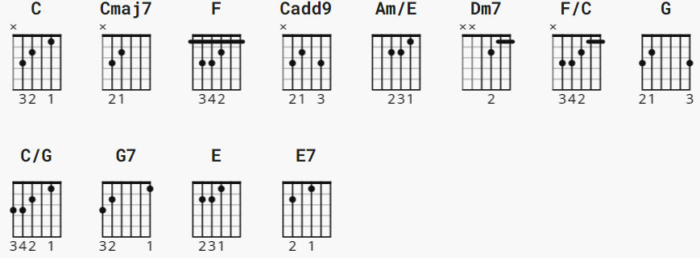

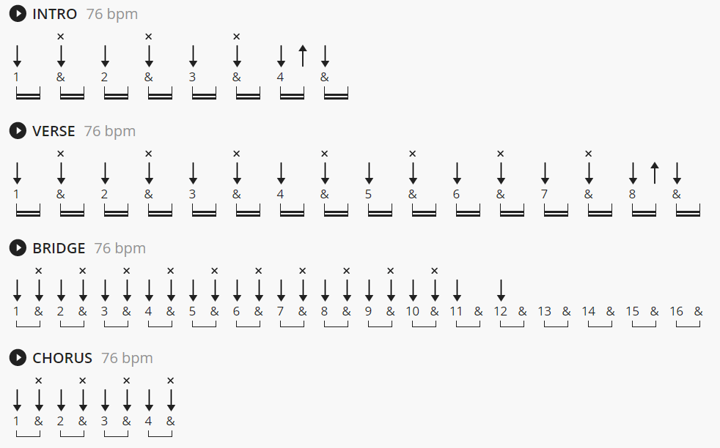

[Intro]
C Cmaj7 F Cadd9 Cmaj7 F
e|----------------|-----------------|----------------|-----------------|
B|------------0---|---------------0-|3---3---3---0---|---------------0-|
G|0---0---0---0---|2---2---2---2h3--|0---0---0---0---|2---2---2---2h3--|
D|2---2---2---2---|3---3---3--------|2---2---2---2---|3---3---3--------|
A|--3---3---3---3-|-----------------|--3---3---3---3-|-----------------|
E|----------------|--1---1---1------|----------------|--1---1---1------|
1 & 2 & 3 & 4 & 1 & 2 & 3 & 4 & 1 & 2 & 3 & 4 & 1 & 2 & 3 & 4 &

[Verse]
Cadd9 Cmaj7 F Cadd9 Cmaj7 F
e|----------------|-----------------|----------------|-----------------|
B|3---3---3---0---|---------------0-|3---3---3---0---|---------------0-|
G|0---0---0---0---|2---2---2---2h3--|0---0---0---0---|2---2---2---2h3--|
D|2---2---2---2---|3---3---3--------|2---2---2---2---|3---3---3--------|
A|--3---3---3---3-|-----------------|--3---3---3---3-|-----------------|
E|----------------|--1---1---1------|----------------|--1---1---1------|
1 & 2 & 3 & 4 & 1 & 2 & 3 & 4 & 1 & 2 & 3 & 4 & 1 & 2 & 3 & 4 &

CHORDS and special voicings

C x-3-2-0-1-0 G 3-x-0-0-0-3
Cmaj7 x-3-2-0-0-0 C/G 3-x-2-0-1-0 or 3-3-2-0-1-0
F x-x-3-2-1-1 G7 3-x-0-0-3-1
Am/E x-x-2-2-1-0 E 0-2-2-1-0-0
E7 0-2-2-1-3-x

Dm7 x-x-0-2-1-1 (or Dm x-x-0-2-3-1)
F/C x-3-x-2-1-1 (or Dm/C x-3-x-2-3-1)

All the C chords in the verses are actually Cadd9 (x-3-2-0-3-0).
Use it for special flavour.

The Dm7 and F/C chords in the Bridges can also be played as
regular Dm and Dm/C respectively (voicings: see above). Choose
whatever sounds best to you.

--
The 3 note walkup at the end of each verse line, chord F, can be:
G2 G2 G3 G4

Imagine Beatles key C

chords: Am/E C C/G Cmaj7 Dm7 E E7 F F/C G G7
To repeat: the C in verses may be better with Cadd9 (???)
Dm7 can be downgraded to Dm; F/C can be downgraded to Dm/C

[Intro]

| C Cmaj7 | F |
| C Cmaj7 | F |

[Verse 1]

C Cmaj7 F ( optional walkup G2 G3 G4 )
Imagine there's no heaven
C Cmaj7 F
It's easy if you try
C Cmaj7 F
No hell below us
C Cmaj7 F
Above us only sky

[Bridge 1]

F Am/E Dm7 F/C
Imagine all the people
G C/G G7
Living for to - day a-hah

[Verse 2]

C Cmaj7 F
Imagine there's no countries
C Cmaj7 F
It isn't hard to do
C Cmaj7 F
Nothing to kill or die for
C Cmaj7 F
And no religion too

[Bridge 2]

F Am/E Dm7 F/C
Imagine all the people
G C/G G7
Living life in peace - you-hou-hou-ou-ou

[Chorus]

F G C Cmaj7 E E7
You may say I'm a dreamer
F G C Cmaj7 E E7
But I'm not the only one
F G C Cmaj7 E E7
I hope some day you'll join us
F G C
And the world will be as one

[Verse 3]

C Cmaj7 F
Imagine no pos - sessions
C Cmaj7 F
I wonder if you can
C Cmaj7 F
No need for greed or hunger
C Cmaj7 F
A brotherhood of man

[Bridge 3]

F Am/E Dm7 F/C
Imagine all the people
G C/G G7
Sharing all the world - you-hou-hou-ou

[Chorus]

F G C Cmaj7 E E7
You may say I'm a dreamer
F G C Cmaj7 E E7
But I'm not the only one
F G C Cmaj7 E E7
I hope some day you'll join us
F G C
And the world will live as one

[no outro]

