In My Life Beatles key A

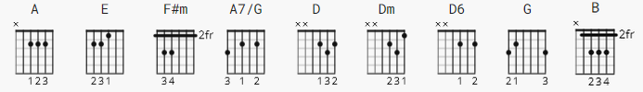

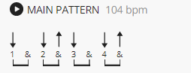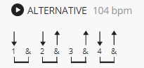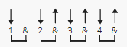

see NOTES at end chords are 2 count except where noted
the first verse only is labeled as example
[Intro]

A - E - A - E

[Verse 1]

A E F#m A7/G
There are places I'll remember
D Dm A (4)
All my li-i-ife though some have changed
E F#m A7/G
Some for ever not for better
D Dm A (4)
Some have go-o-one, and some remain.
F#m (4) D6
All these places have their moments
G (4) A (4)
With lovers and friends, I still can recall
F#m (4) B
Some are dead and some are living
Dm (4) A
In my-y-y-y life, I've loved them all

A - E

[Verse 2]

A E F#m A7/G
But of all these friends and lovers
D Dm A
There is no one compared with you
E F#m A7/G
And these memories lose their meaning
D Dm A
When I think of love as something new
F#m D6
Thought I know I'll never lose affection
G A
For people and things that went before

F#m B
I know I'll often stop and think about them
Dm A
In my-y-y life I'll love you more

[harpsichord]:

A E F#m A7/G
D Dm A
A E F#m A7/G
D Dm A

F#m D6
Thought I know I'll never lose affection
G A
For people and things that went before
F#m B
I know I'll often stop and think about them
Dm A
In my-y-y life I'll love you more

A - E

Dm A E E A
In my-y-y-y life I'll love you more

[no outro]

------------------
NOTES: this is from version 2 at UG key A
We had discussed using ver. 1 which is key G (capo 2 makes A )
but decided that instead of fingering Cm, Dm would be easier.

key A matches an album.

I included here the suggested strums from Version 1.
Version 1 also has several filler tabs, not included here,
which would be easy to translate.

