Itchycoo Park Small Faces 1967 chording G, key A

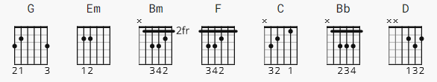

Capo II

G Em G

G Bm
Over bridge of sighs,
F C
to rest my eyes in shades of green
G Bm
Under dreamin' spires,
F C
to Itchycoo Park, that's where I've been

G
What did you do there? G 3 counts, F 1 count, C 4 counts
F C
I got high
G
What did you feel there?
F C
Well, I cried
G
But why the tears there?
F C
I'll tell you why

G Em
It's all too beautiful
G Em
It's all too beautiful
G Em
It's all too beautiful
G Em
It's all too beautiful

G Bb
I feel inclined, to blow my mind,
F C G |F C| - 2 counts ea.
get hung up, feed the ducks with a bun
Bb
They all come out to groove about,
F C D
be nice and have fun in the sun

G Bm F
Tell you what I'll do (what will you do?)
C
I'd like to go there now with you
G Bm F
You can miss out school (won't that be cool)
C
Why go to learn the words of fools?

G
What will we do there?
F C
We'll get high
G
What will we touch there?
F C
We'll touch the sky
G
But why the tears there?
F C
I'll tell you why

G Em
It's all too beautiful
G Em
It's all too beautiful
G Em
It's all too beautiful
G Em
It's all too beautiful

G Bb
I feel inclined, to blow my mind,
F C G
get hung up, feed the ducks with a bun
Bb
They all come out to groove about,
F C D
be nice and have fun in the sun

G Em
It's all too beautiful
G Em
It's all too beautiful
G Em
It's all too beautiful
G Em
It's all too beautiful

[outro]

[instrumental 3 bars] Then REPEAT " It's all too ... 4 x
---------------------------------
NOTE:

The following link has one long text file with chords in all the major keys.

https://tabs.ultimate-guitar.com/tab/small-faces/itchycoo-park-chords-1189787

