Jack and Diane Mellencamp key A

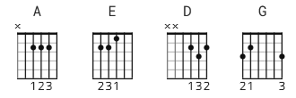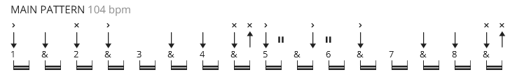

[Intro]

(use barre chords)

A E A E D D (x3)

[Verse 1]

A E D E
A little ditty 'bout Jack and Diane
A E D E A
Two American kids growin' up in the heartland
A E D E
Jack, he's gonna be a football star
A E D E A
Diane debutante, back seat of Jacky's car

[Instrumental]

A E D E A E D A

[Verse 2]

A E D E
Suckin' on chili dog outside the Tasty Freeze
A E D E A
Diane sittin' on Jacky's lap, he got his hands between her knees
A E D E
Jacky says "Hey Diane, let's run off behind a shady tree"
A E D E A
Dribble off those Bobby Brooks, let me do what I please, sayin'

[Chorus]

A E D E
Oh yeah, life goes on
A E D E
Long after the thrill of livin' is gone, sayin'
A E D E
Oh yeah, life goes on
A E D E A
Long after the thrill of livin' is gone, they walk on
[Instrumental]

A E A E D D x2

[Verse 3]

A E D E
Jack, he sits back, collects his thoughts for a moment
A E D E A
Scratches his head and does his best James Dean
A E D E
"Well then there Diane, we gotta run off to the city"
A E D E A
Diane says, "Baby you ain't missing a thing", but Jacky says

[Chorus]

A E D E
Oh yeah, life goes on
A E D E
Long after the thrill of livin' is gone
A E D E
Oh yeah, life goes on
A E D E A
Long after the thrill of livin' is gone

[Drum Solo]

(A cappella but these are the chords)
A D E
So let it rock, let it roll
A D G D
Let the Bible belt come and save my soul
A D G D
Holdin' on to sixteen as long as you can
A D E A
Change is comin' 'round real soon, make us women and men

[Instrumental]

A E D E A E D A
[Chorus]

A E D E
Oh yeah, life goes on
A E D E
Long after the thrill of livin' is gone
A E D E
Oh yeah, life goes on
A E D E A
Long after the thrill of livin' is gone

A E D E
A little ditty 'bout Jack and Diane
A E D E A
Two American kids doin' the best they can

[Outro]

A E A E D D

(repeat and fade)

