Joy To The World Three Dog Night key D

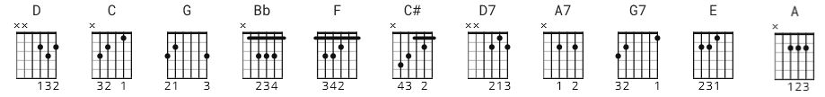

You may like version 2 on UG
[Intro]
D C G Bb
F
C C# D

[Verse 1]

N.C. C C# D
Jeremiah was a bullfrog
N.C. C C# D
Was a good friend of mine
D D7 G Bb
I never understood a single word he said
D A7 D
But I helped him drink his wine
G7 A7 D
And he always had some mighty fine wine

[Chorus]

D
Singin'… Joy to the world
A7 D
All the boys and girls, now
D D7 G Bb
Joy to the fishes in the deep blue sea
D A7 D C C# D
Joy to you and me

[Verse 2]

N.C. C C# D
If I were the king of the world
N.C. C C# D
Tell you what I'd do
D D7 G Bb
I'd throw away the cars and the bars and the wars
D A7 D
And make sweet love to you
[Chorus]

D
Singin'… Joy to the world
A7 D
All the boys and girls
D D7 G Bb
Joy to the fishes in the deep blue sea
D A7 D
Joy to you and me

[Solo]

D D A7 D
D D7 G Bb D A7 D
C C# D

[Verse 3]

N.C. C C# D
You know I love the ladies
N.C. C C# D
I love to have my fun
D D7 G Bb
I'm a high life flyer and a rainbow rider
D A7 D
A straight shootin' son-of-a-gun
G7 A7 D
I said, a straight shootin' son-of-a-gun

[Chorus]

D
Singin'… Joy to the world
A7 D
All the boys and girls
D D7 G Bb
Joy to the fishes in the deep blue sea
D A7 D
Joy to you and me

[Bridge]

E D A
Joy…........ to the world
E D A
All…........ the boys and girls
E D A
Joy…........ to the world
E D A
Joy….........to you and me
[Chorus]

D
Joy to the world
A7 D
All the boys and girls
D D7 G Bb
Joy to the fishes in the deep blue sea
D A7 D
Joy to you and me

[Outro]

D
Joy to the world
D A7 D
Joy to you and me

D
Joy to the world
A7 D
All the boys and girls
D D7 G Bb
Joy to the fishes in the deep blue sea
D A7 D
Joy to you and me

D
Joy to the world
A7 D
All the boys and girls
D D7 G Bb
Joy to the fishes in the deep blue sea
D A7 D
Joy to you and me

D
Joy to the world
A7 D
All the boys and girls, now
D D7 G Bb
Joy to the fishes in the deep blue sea
D A7 D
Joy to you and me

(fade out)

