Jumpin'Jack Flash Rolling Stones key A

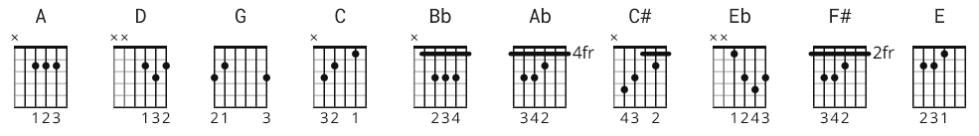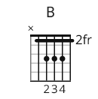

Capo I

A D G 3x
A
A
Watch it!

A G 2x

A G A A G
I was born in a cross-fire hurricane
A G A A G
And I howled at my ma in the driving rain
C G D A
But it's all right now, in fact it's a gas
C G D
But it's all right, I'm Jumpin' Jack Flash
A
It's a gas gas gas

A G 2x

A G A A G
I was raised by a toothless, bearded hag
A G A A G
I was schooled with a strap right across my back
C G D A
But it's all right now, in fact it's a gas
C G D
But it's all right, I'm Jumpin' Jack Flash
A
It's a gas gas gas

A G 4x

A G A A G
I was drowned, I was washed up and left for dead
A G A A G
I fell down to my feet and I saw they bled
A G A G
I frowned at the crumbs of a crust of bread, yeah, yeah, yeah

A G A A G
I was crowned with a spike right thru my head
C G D A
But it's all right now, in fact it's a gas
C G D
But it's all right, I'm Jumpin' Jack Flash
A
It's a gas gas gas

A D G
Jumping Jack Flash, it's a gas 4x

* Alternates:

Open

A = Bb
G = Ab
C = C#
D = Eb

Capo IV (for a somewhat dirtier sound)

A = F#
G = E
C = A
D = B

