Kokomo The Beach Boys key C

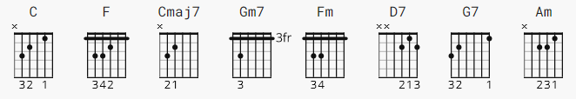

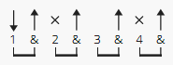 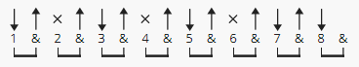 116 bpm
verse chorus

[no Intro yet]

C
Aruba, Jamaica, ooh I wanna take ya
F
Bermuda, Bahama, come on pretty mama
C F
Key Largo, Montego, baby why don't we go, Jamaica

C Cmaj7
Off the Florida Keys
Gm7 F
There's a place called Kokomo
Fm C D7 G7
That's where you wanna go to get away from it all
C Cmaj7
Bodies in the sand
Gm7 F
Tropical drink melting in your hand
Fm C D7
We'll be falling in love to the rhythm of a steel drum band
G7 C
Down in Kokomo

[Chorus]
C
Aruba, Jamaica, ooh I wanna take ya to
F
Bermuda, Bahama, come on pretty mama
C F
Key Largo Montego, ooh I wanna take her down to Kokomo
Fm C
We'll get there fast and then we'll take it slow
Am D7
That's where we wanna go
G7 C
Way down in Kokomo

C
Martinique, that Montserrat mystique
C Cmaj7
We'll put out to sea
Gm7 F
And we'll perfect our chemistry
Fm C D7 G7
By and by we'll defy a little bit of gravity
C Cmaj7
Afternoon delight
Gm7 F
Cocktails and moonlit nights
Fm C D7
That dreamy look in your eye give me a tropical contact high
G7 C
Way down in Kokomo

[Chorus]
C
Aruba, Jamaica, ooh I wanna take ya to
F
Bermuda, Bahama, come on pretty mama
C F
Key Largo, Montego, ooh I wanna take her down to Kokomo
Fm C
We'll get there fast and then we'll take it slow
Am D7
That's where we wanna go
G7 C
Way down in Kokomo

C
Port Au Prince, I wanna catch a glimpse

[Sax Solo]
C Cmaj7 Gm7 F Fm C D7 G7

C Cmaj7
Everybody knows
Gm7 F
A little place like Kokomo
Fm C D7 G7
Now if you wanna go and get away from it all
C
Go down to Kokomo
[Chorus]
C
Aruba, Jamaica, ooh I wanna take ya to
F
Bermuda, Bahama, come on pretty mama
C F
Key Largo Montego, ooh I wanna take her down to Kokomo
Fm C
We'll get there fast and then we'll take it slow
Am D7
That's where we wanna go
G7 C
Way down in Kokomo

C
Aruba, Jamaica, ooh I wanna take ya to
F
Bermuda, Bahama, come on pretty mama
C F
Key Largo Montego, ooh I wanna take her down to Kokomo
Fm C
We'll get there fast and then we'll take it slow
Am D7
That's where we wanna go
G7 C
Way down in Kokomo

