Lemon Tree Peter Paul Mary

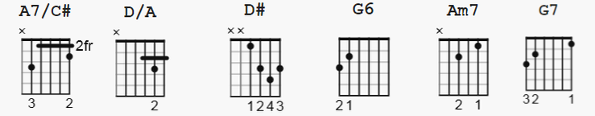
Capo II

[Intro] ( BM7 and Gmaj7 used only in Intro )
D A7/C# Bm7 A7 Gmaj7 A D A D

[Verse 1]
D A7 D D A7 D
When I was just a lad of ten, my father said to me,
D A7/C# Bm D/A G6 A7 D
"Come here and take a lesson from the lovely lemon tree."
G F G G F Em
"Don't put your faith in love, my boy", my father said to me,
D# G Am7 D7 G7
"I fear you'll find that love is like the lovely lemon tree."

[Chorus]
C F C F C F G7
Lemon tree very pretty and the lemon flower is sweet
G7 G7 G7 C
but the fruit of the poor lemon is impossible to eat.
C F C F C F G7
Lemon tree very pretty and the lemon flower is sweet
G7 G7 G7 C A7
but the fruit of the poor lemon is impossible to eat.

[Verse 2]
D A7 D D A7 D
One day beneath the lemon tree, my love and I did lie
D A7/C# Bm D/A G6 A7 D
A girl so sweet that when she smiled the stars rose in the sky.
G F G G F Em
We passed that summer lost in love beneath the lemon tree
D# G Am7 D7 G7
the music of her laughter hid my father's words from me:

[Chorus]
C F C F C F G7
Lemon tree very pretty and the lemon flower is sweet
G7 G7 G7 C
but the fruit of the poor lemon is impossible to eat.
C F C F C F G7
Lemon tree very pretty and the lemon flower is sweet
G7 G7 G7 C A7
but the fruit of the poor lemon is impossible to eat.

[Verse 3]
D A7 D D A7 D
One day she left without a word. She took away the sun.
D A7/C# Bm D/A G6 A7 D
And in the dark she left behind, I knew what she had done.
G F G G F Em
She'd left me for another, it's a common tale but true.
D# G Am7 D7 G7
A sadder man but wiser now I sing these words to you:

[Chorus]
C F C F C F G7
Lemon tree very pretty and the lemon flower is sweet
G7 G7 G7 C
but the fruit of the poor lemon is impossible to eat.
C F C F C F G7
Lemon tree very pretty and the lemon flower is sweet
G7 G7 G7 C
but the fruit of the poor lemon is impossible to eat.

[Outro]
G
Lemon tree (lemon tree)
C
Lemon tree (lemon tree)
G
Lemon tree (lemon tree)
C C
Lemon tree (lemon tree)

