Let It Ride (flatted) Bachman-Turner Overdrive II

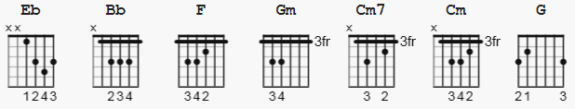

Note: play a hammer on with your ring finger during verse Gm

[Intro]

Eb Bb F Gm Cm7 Cm Gm
Eb Bb F Gm Cm7 Cm Gm

Eb Bb F G
Goodbye, hard life
Cm7 Cm Gm
Don't cry, would you let it ride?
Eb Bb F G
Goodbye, hard life
Cm7 Cm Gm
Don't cry, would you let it ride

[Verse 1]
Gm
You can't see the mornin', but I can see the light
Gm
Try try try , let it ride
Gm
While you've been out runnin'
Gm
I've been waitin half the night
Gm
Try, try, try, let it ride

[Chorus]
Gm Eb Bb F Gm
And would you cry if I told you that I lied?
Cm Gm
Or would you say goodbye or would you let it ride?
Eb Bb Gm
And would you cry if I told you that I lied?
Cm Gm
And would you say goodbye or would you let it ride?

[Verse 2]
Gm
Seems my life is not complete, I never see you smile
Gm
Try, try, try, let it ride
Gm
Baby you want the forgivin kind and that's just not my style
Gm
Try, try, try, let it ride

[Chorus]

Gm Eb Bb F Gm
And would you cry if I told you that I lied?
Cm Gm
And would you say goodbye, would you let it ride?
Gm Eb Bb F Gm
And would you cry if I told you that I lied?
Cm Gm
And would you say goodbye, would you let it ride?

[Verse 3]

Gm
I've been doin' things worthwhile, you've been bookin' time
Gm
Try, try, try, let it ride

[Chorus]
Gm Eb Bb F Gm
And would you cry if I told you that I lied?
Cm Gm
And would you say goodbye, would you let it ride?
Gm Eb Bb F Gm
And would you cry if I told you that I lied?
Cm Gm
And would you say goodbye, would you let it ride?

Gm
Would you let it ride, would you let it ride?
Gm
Would you let it ride, would you let it ride?

[Bridge]

Gm
Try, try, try, let it ride
Gm
Try, try, try, let it ride
Gm
Try, try, try, let it ride
Gm
Try, try, try, let it ride
Gm
Try, try, try, let it ride

[Outro]
Gm
Would you let it ride? Would you let it ride?
Gm
Would you let it ride? would you let it ride?

------------------------------------
hardcore electric guitar tutorial different key https://www.youtube.com/watch?v=W7eR6vMWy7E

