Let It Ride Bachman-Turner Overdrive II

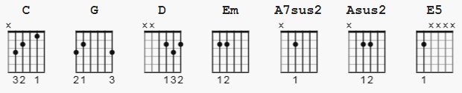

Capo 2 A7sus2: x02000 Asus2: x02200

[Intro]

C G D Em A7sus2 Asus2 Em (X2)

[Verse 1]

C G D Em
Goodbye, hard life
A7sus2 Asus2 Em
Don't cry, would you let it ride?
C G D Em
Goodbye, hard life
A7sus2 Asus2 E5
Don't cry, would you let it ride?

[Riff]

E5
e|----------------------------|
B|----------------------------|
G|----------------------------|
D|-2-x-x-2-x-x-2-x-x-2-2------|
A|-2-x-x-2-x-x-2-x-x-2-2------|
E|-0-x-x-0-x-x-0-x-x-0-3------|

E5
You can't see the mornin', but I can see the light
E5
Ride, ride, ride, let it ride
E5
While you've been out runnin' I've been waitin' half the night
E5 D
Ride, ride, ride, let it ride
[Chorus]

C G D Em
And would you cry if I told you that I lied
A7sus2 Asus2
And would you say goodbye
Em
Or would you let it ride?
C G D Em
And would you cry if I told you that I lied
A7sus2 Asus2
And would you say goodbye
E5
Or would you let it ride?

[Verse 2]

E5
Babe, my life is not complete, I never see you smile
E5
Ride, ride, ride, let it ride
E5
Baby, you want the forgivin' kind and that's just not my style
E5 D
Ride, ride, ride, let it ride

[Chorus]

C G D Em
And would you cry if I told you that I lied
A7sus2 Asus2
And would you say goodbye
Em
Or would you let it ride?
C G D Em
And would you cry if I told you that I lied
A7sus2 Asus2
And would you say goodbye
E5
Or would you let it ride?

[Solo]

E5

E5
I've been doin' things worthwhile, you've been bookin' time
D
Ride, ride, ride, let it ride
[Chorus]

C G D Em
And would you cry if I told you that I lied
A7sus2 Asus2
And would you say goodbye
Em
Or would you let it ride?
C G D Em
And would you cry if I told you that I lied
A7sus2 Asus2
And would you say goodbye
E5
Or would you let it ride?

[Bridge]

E5
Would you let it ride?
Would you let it ride?
Would you let it ride?
Would you let it ride?

[Outro]

N.C.
Ride, ride, ride, let it ride (x5)
Would you let it ride? (x4)

C G D Em A7sus2 Asus2 Em (X4)

