Let It Be - The Beatles

Play G: key C : Capo: 5th fret : Tab#1, Tab#2 last sheet

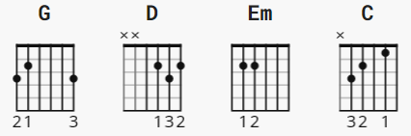

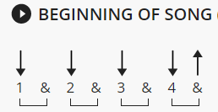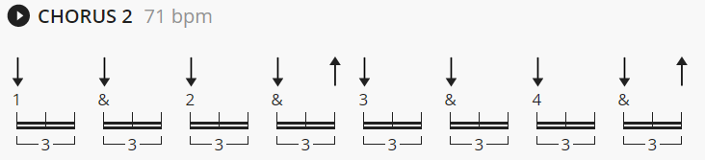
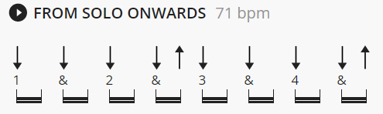

[Intro]
| G | D | Em | C |
| G | D | C | G |
(TAB*1)

[Verse 1]
G D Em C
When I find myself in times of trouble mother Mary comes to me
G D C G (walkdown= C G A G )
Speaking words of wisdom, let it be
(TAB*1)
G D Em C
And in my hour of darkness she is standing right in front of me
G D C G
Speaking words of wisdom, let it be
(TAB*1)

[Chorus]
Em D C G
Let it be, let it be, let it be, let it be
G D C G
Whisper words of wisdom, let it be
(TAB*1)

[Verse 2]
G D Em C
And when the broken-hearted people living in the world agree
G D C G
There will be an answer, let it be
(TAB*1)
G D Em C
For though they may be parted, there is still a chance that they will see
G D C G
There will be an answer, let it be
(TAB*1)

[Chorus]
Em D C G
Let it be, let it be, let it be, let it be
G D C G
Yeah, there will be an answer, let it be
(TAB*1)
Em D C G
Let it be, let it be, let it be, let it be
G D C G
Whisper words of wisdom, let it be
(TAB*1)

[Interlude]
| C | G | D C | G |
(TAB*2)
| C | G | D C | G |
(TAB*2)

[Solo]
| G | D | Em | C |
| G | D | C | G |
(TAB*1)
| G | D | Em | C |
| G | D | C | G |
(TAB*1)

[Chorus]
Em D C G
Let it be, let it be, let it be, yeah, let it be
G D C G
Whisper words of wisdom, let it be
(TAB*1)

[Verse 3]
G D Em C
And when the night is cloudy, there is still a light that shines on me
G D C G
Shine until tomorrow, let it be
(TAB*1)
G D Em C
I wake up to the sound of music mother Mary comes to me
G D C G
Speaking words of wisdom, let it be
(TAB*1)

[Chorus]
Em D C G
Let it be, let it be, let it be, yeah, let it be
G D C G
There will be an answer, let it be
(TAB*1)
Em D C G
Let it be, let it be, let it be, yeah, let it be
G D C G
Whisper words of wisdom, let it be
(TAB*1)

[Coda]
| C | G | D C | G |
(TAB*2)

C G
1 + 2 + 3 + 4 + 1 + 2 + 3 + 4 +
TAB*1: e|0---------------|3---------------|
B|1---------------|0---------------|
G|0---------------|0---------------|
D|2---------------|0---------------|
A|3-------2---0---|----------------|
E|----------------|3---------------|

C G D C G
1 + 2 + 3 + 4 + 1 + 2 + 3 + 4 + 1 + 2 + 3 + 4 + 1 + 2 + 3 + 4 +
TAB*2: e|0---------------|3---------------|2-------0-------|3---------------|
B|1---------------|0---------------|3-------1-------|0---------------|
G|0---------------|0---------------|2-------0-------|0---------------|
D|2---------------|0---------------|0-------2-------|0---------------|
A|3-------2---0---|----------------|--------3-------|----------------|
E|----------------|3-------1---0---|----------------|3---------------|

