Listen To The Music Doobie Bros key E

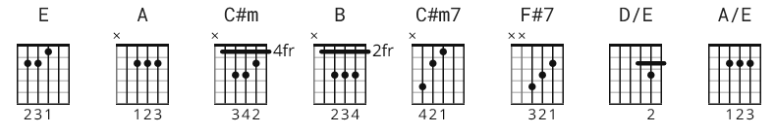

106 bpm

Play as bar chords E/A riff on 12th fret, C#m/B/A - 9th/7th/5th fret,
F#7 - 14th fret.

[Intro]

|E | A |E | A |
/ / / / / / / / / / / / / / / /

|E | A |E | A |
/ / / / / / / / / / / / / / / /

[Verse]

E A
Don’t you feel it growin’, day by day
E C#m
People gettin’ ready for the news
B A
Some are happy, some are sad
A
Oh, we got to let the music

|E | A |
/ / / / / / / /
play mm mm

E
What the people need
A
Is a way to make ’em smile
E C#m
It ain’t so hard to do if you know how
B
Gotta get a message
A
Get it on through
E
Oh now mama, don’t you ask me why
[Chorus]

C#m7 A
Whoa oh whoaaa listen to the music
C#m7 A
Whoa oh whoaaa listen to the music
C#m7 A
Whoa oh whoaaa listen to the music
F#7 A
All the tiiii- i-i- iiime

[Instrumental]

|E | A |E | A |
/ / / / / / / / / / / / / / / /

[Verse]

E
Well I know, you know better
A
Everything I say
E C#m
Meet me in the country for a day
B
We’ll be happy
A
And we’ll da-a-ance
A
Oh, we’re gonna dance our blues

|E | A |
/ / / / / / / /
away
E
And if I’m feelin’ good to you
A
And you’re feelin’ good to me
E C#m
There ain’t nothin’ we can’t do or say
B A
Feelin’ good, feeling fine
A E
Oh, baby, let the music play
[Chorus]

C#m7 A
Whoa oh whoaaa listen to the music
C#m7 A
Whoa oh whoaaa listen to the music
C#m7 A
Whoa oh whoaaa listen to the music
F#7 A
All the tiiii- i-i- iiime

[Bridge]

E D/E
Like a lazy flowing river
A/E E
Surrounding castles in the sky
E D/E
And the crowd is growing bigger
A
List’nin’ for the happy sounds
A
And I got to let them fly

[Chorus]

C#m7 A
Whoa oh whoaaa listen to the music
C#m7 A
Whoa oh whoaaa listen to the music
C#m7 A
Whoa oh whoaaa listen to the music
F#7 A
All the tiiii- i-i- iiime

C#m7 A
Whoa oh whoaaa listen to the music
C#m7 A
Whoa oh whoaaa listen to the music
C#m7 A
Whoa oh whoaaa listen to the music
F#7 A
All the tiiii- i-i- iiime

C#m7 A
Whoa oh whoaaa listen to the music
C#m7 A
Whoa oh whoaaa listen to the music
C#m7 A
Whoa oh whoaaa listen to the music
F#7 A
All the tiiii- i-i- iiime

(fade)

