Lookin' Out My Back Door Creedence Clearwater Revival/Fogerty
(font 11 pt)
key G

CAPO 3 --- I'm not sure, but I think the chords are 1 octave above
the recording... but it still sounds OK. I tried a translation to open chords and barre chords with no capo, and they suck.

chords in alphabetic order: A C D E Em F F# F#m G

[intro]: mute x8 G Em C G D G
(8 beat mute strums) ==> G (4) Em (4) C (2) G (2) D (2) G (2) (beats)

[Verse 1]

G Em
Just got home from Illinois, lock the front door, oh boy !
C G D
Got to sit down, take a rest on the porch.
G Em
Imagination sets in, pretty soon I'm singing,
C G D G
doo, doo, doo, lookin' out my back door.

[Verse 2]

G Em
There's a giant doing cartwheels, a statue wearin' high heels,
C G D
look at all the happy creatures dancing on the lawn.
G Em
A dinosaur Victrola, listening to Buck Owens
C G D G
doo, doo, doo, lookin' out my back door.

[Bridge 1]

D C G
Tambourines and elephants are playing in the band,
Em D
won't you take a ride on the flyin' spoon ? Doo, doo doo
G Em
Wond'rous apparition, provided by magician,
C G D G
doo, doo, doo, lookin' out my back door.

[Solo 1]

G Em C G D

G Em C G D G

[Bridge 2]

D C G
Tambourines and elephants are playing in the band,
Em D
won't you take a ride on the flyin' spoon ? Doo, doo doo

G Em
Bother me tomorrow, to-day I'll buy no sorrow,
C G D G
doo, doo, doo, lookin' out my back door.

[break - key change]: solo you play :

G F# F E D A A F#m E
1-7 & 8 & (4) (4) (4) (2) (2) ==> count + (beats)

[Verse 3] Note change in key

A F#m
All our troubles Illinois, lock the front door, oh boy !
D A E
Look at all the happy creatures dancing on the lawn.

slow down tempo

A F#m
Bother me tomorrow, to-day I'll buy no sorrow
D A E A
doo, doo, doo, lookin' out my back door.

[ outro ]

strum mute D A E A
(4) (2) ea. DUDD (fast)
----------------
rhyhthm:

Intro: 1 &a2e&a3 &a4e&a downbeat and 1, 3

D and Bm: 1 & 2 &a 3 & 4 &a or: B D udu - D is a little
D xu D xu Dxu Duxu stretched and louder than d

my own interpretation of the MELODY: adjust per your chord choices

e|------------------------------------|
B|------------------------------------|
G|--2/4--2/4--2 ----------------------|
D|---------------4--0--2--4--2--0-----|
A|------------------------------------|
E|------------------------------------|
Sample Lead and rhythm per some website

This looks like it's in the key of A rather than G.
It seems to be a series of standard open chords played 4 strings at
a time: A F#m D E. The open D, bottom 4 strings open, seem to sound
like crap. So the point is made: alternate your stumming with 4 strings

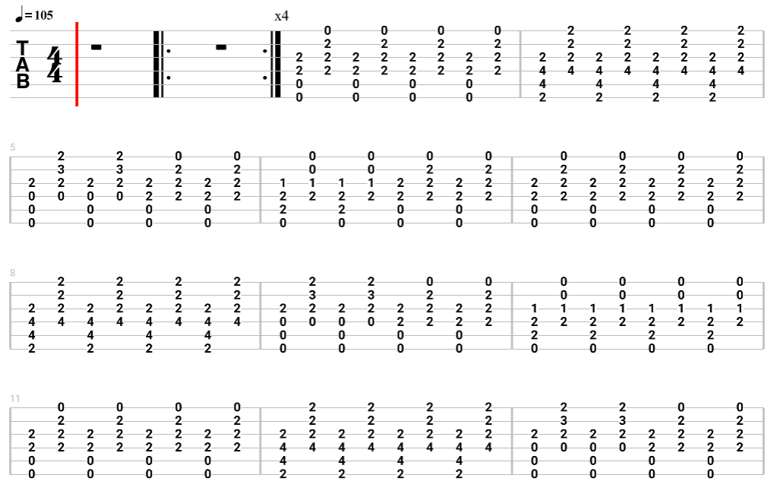
Lookin' Out My Back Door - Suggested BASS, probably in key F
Manually translate ?? frets for say key G
This is more or less correct to the original. ??

Intro:
G|------------|-------------------------------------------|
D|-NO BASS ON-|-8---8------5---5--------8---------5-7-8---|
A|-FIRST PART-|---8---88-----5---55---6-----8---88------8-|
E|------------|---------------------------6---------------|

Verse:
G|----------------------------------------------------------|
D|-8---8----5-5-5-5---8--------------5-7---8---8----5-5-5-5-|
A|---8---8----------6-----8---8----88--------8---8----------|
E|----------------------6-------8---------------------------|

G|----------------------|
D|---8----------5-7-8---|
A|-6-----8---88-------8-|
E|-----6----------------|

Repeat Verse:

Bridge:
G|-----------------------------------------------|
D|-----------------------------5-------------5-7-|
A|-88888888---6666----------8----5---8-8---88----|
E|-----------------6666---6----------------------|
Ending 2nd Time:
G|-------------------------------------------| |--------------|
D|-8---8--8---5---5--5----8----------5-7-8---| |-----5-7-8--8-|
A|---8---8------5---5---6-----8---88-------8-| |--88-------8--|
E|--------------------------6----------------| |--------------|

For Solo Use Verse:
Repeat Bridge:
Break with Guitar & Into Key Change:

Solo 2:
G|---------|------------------------------------------------|
D|-NO Bass-|------------------------5-----------------------|
A|---------|---------5---5----3---3----3-3--------------0-2-|
E|---------|-6-5-4-3---3----1---------------5-5---3-3-33----|

Part Verse:
G|------------------------------------------|
D|---5---5------------3-3---------5----5555-|
A|-3---3------7---7--------3-3------5-------|
E|----------5---5---------------------------|

Half Tempo Bit: Outro:
G|-----------------------------------------| |-------------------|
D|-----------------------------------------| |-3-3---------------|
A|-3---3-------7---7---8-8---------0-2-3-3-| |-----3-3---0-2-3-3-|
E|---3---3---5---5--------8-8---33------3--| |---------33-----3--|

