Losing My Religion R.E.M key Am

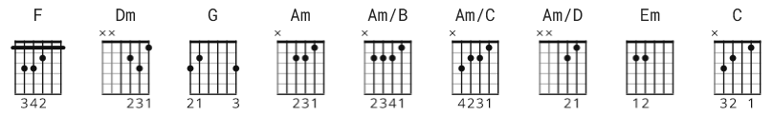

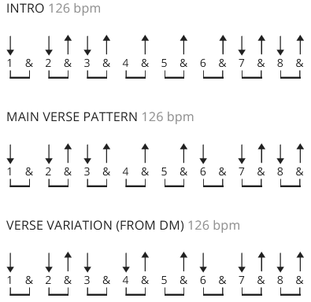

[Intro]

F Dm G Am Am/B Am/C Am/D Am
F Dm G Am G

[Verse 1]

Am Em
Oh, life is bigger

It's bigger than you
Am
And you are not me.
Em
The lengths that I will go to,
Am Em
The distance in your eyes,
Dm
Oh no, I've said too much,
G
I set it up.

[Chorus]

Am
That's me in the corner,
Em
That's me in the spotlight
Am
Losing my religion.
Em
Trying to keep up with you.
Am Em
And I don't know if I can do it.
Dm
Oh no, I've said too much,
G
I haven't said enough.

[Bridge]

G(4) F(4) ( counts )
I thought that I heard you laughing,
Dm(2) G(2) Am(2)Am/B Am/C Am/D (1 ea)
I thought that I heard you sing.
Am(1)F(4) Dm(2) G(2) Am(4) G(4)
I think I thought I saw you try.

[Verse 2]

Am Em
Every whisper of every waking hour
Am
I'm choosing my confessions,
Em
Trying to keep an eye on you
Am Em
Like a hurt lost and blinded fool, fool
Dm
Oh no, I've said too much,
G
I set it up.

[Verse 3]

Am
Consider this, consider this,
Em
The hint of a century,
Am
Consider this: the slip
Em
That brought me to my knees failed.
Am
What if all these fantasies
Em
Come flailing around?
Dm G
Now I've said too much.
[Bridge]

G F
I thought that I heard you laughing,
Dm G Am Am/B Am/C Am/D
I thought that I heard you sing.
Am F Dm G Am G
I think I thought I saw you try.

[Link]

Am G
e|-12-12-12-10-10-10-10-10-8-8-8-5-5-5-5-5-|
B|-----------------------------------------|
G|-----------------------------------------|
D|-----------------------------------------|
A|-----------------------------------------|
E|-----------------------------------------|

F G
e|-12-12-12-10-10-10-10-10-8-8-8-5-5-5-5-5-|
B|-----------------------------------------|
G|-----------------------------------------|
D|-----------------------------------------|
A|-----------------------------------------|
E|-----------------------------------------|

C Dm
But that was just a dream,
C Dm
That was just a dream.

[Chorus]

Am
That's me in the corner,
Em
That's me in the spotlight
Am
Losing my religion.
Em
Trying to keep up with you.
Am Em
And I don't know if I can do it.
Dm
Oh no, I've said too much,
G
I haven't said enough.

[Bridge]

G F
I thought that I heard you laughing,
Dm G Am Am/B Am/C Am/D
I thought that I heard you sing.
Am F Dm G Am Am/B Am/C Am/D Am
I think I thought I saw you try.
F Dm G
But that was just a dream,
Am Am/B Am/C Am/D Am
Try, cry, why, try.
F Dm G Am G
That was just a dream, just a dream, just a dream, dream.

[Outro]

Am
e|-12-12-12-12-12-12-12-12-|
B|-------------------------|
G|-------------------------| x7
D|-------------------------|
A|-------------------------|
E|-------------------------|

e|-12-10-------10----------|-----------------|
B|-------13-10----13-10-13-|-10--------------|
G|-------------------------|-----------------|
D|-------------------------|-----------------|
A|-------------------------|-----------------|
E|-------------------------|-----------------|

