Love Is Strange Mickey and Sylvia key C

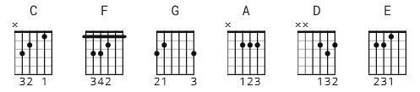

[Intro]

C F G 3x
C

C C F
Love (humm umm)
F C C F
Love is strange (yeah yeah)
F C C F
Lot of people (humm umm)
F C F G
Take for a game

C C F
Once you get it (humm umm)
C C F
You never wanna quit (no no)
C C F
After you've had it (yeah yeah)
C F G
You're in an awful fix

C C F
Many people (humm umm)
C C F
Don't understand (no no)
C C F
They think loving (yeah yeah)
C F G
Is money in the hand

C C F
Your sweet loving (humm umm)
C C F
Is better than a kiss (yeah yeah)
C C F
When you leave me (humm umm)
C F G
Sweet kisses I miss

C F G 3x
C
C F 3x
C
C F G
Sylvia?
C F G
Yes, Mickey
C F G
How do you call your lover boy?
C F G
Come here lover boy
C F G
And if he doesn't answer?
C F G
Oh, lover boy
C F G
And if he still doesn't answer?

I simply say
C F C
Baby, oh baby
F C F C
My sweet baby, you're the one
C C F C C F
Baby,(humm umm) oh baby (yeah yeah)
C C F C
My sweet baby,(humm umm), you're the one

C F 3x

* Alternate:

Capo III

C = A
F = D
G = E

