Love Me Do Beatles key A (simplified)

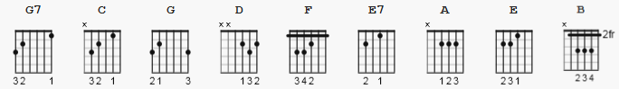

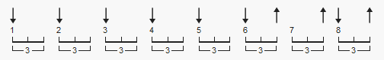 148 bpm strum accents on 2 and 4
justin: D DuD D 1 2&3 4

NOTE: a simpler version can be constructed by using A, instead of A7,
and removing G. Justins version is all down strums on beats; no up.
NOTE: Beatles Album from youtube Please Please Me Do with 12 songs is slightly out of pitch.

[Intro]

|A D| A D| A D| A |

[Chorus]:

A D
Love, love me do
A D
You know I love you
A D
I'll always be true
D D (1 strum, 8 count )(2 NS) A
So pleeeeeease... Love me do
| A |
oh Love me do

[chorus]:

A D
Love, love me do
A D
You know I love you
A D
I'll always be true
D N.C. A
So pleeeeeease... Love me do
| A |
oh Love me do

[bridge]

E D G A
Someone to love, somebody new
E D G A
Someone to love, someone like you

[chorus]:

A D
Love, love me do
A D
You know I love you
A D
I'll always be true
D N.C. A
So pleeeeeease... Love me do

[solo -bridge chords];

harmonica; 7 slow 4 counts
you may count the double beats
so you'd 56 instead of 28

[chorus]:

A D
Love, love me do
A D
You know I love you
A D
I'll always be true
D A
So pleeeeeease... Love me do

[outro]

A D A D
Love me do, Yeah love me do, yeah
A D
love me do...

harmonica single notes: D C# B E

