Love Me Do Beatles key G7 ( or G )

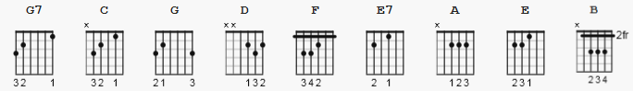

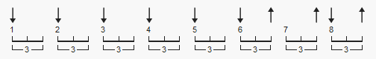 148 bpm alternate D D D D D Du uDu
1 2 3 4 5 6e 7 a8e

NOTE: a simpler version can be constructed by using G, instead of G7,
and removing F.

[Intro] ( 11 pt. font)

G7 C G7 C G7 C G7

G7 C
Love, love me do
G7 C
You know I love you
G7 C
I'll always be true
C N.C. G
So pleeeeeease... Love me do

G7 C
Love, love me do
G7 C
You know I love you
G7 C
I'll always be true
C N.C. G
So pleeeeeease... Love me do

D C F G
Someone to love, somebody new
D C F G
Someone to love, someone like you

G7 C
Love, love me do
G7 C
You know I love you
G7 C
I'll always be true
C N.C. G
So pleeeeeease... Love me do

[Instrumental]

D C F G
D C F G
8 + 6 + 2 counts here...TBD

G7 C
Love, love me do
G7 C
You know I love you
G7 C
I'll always be true
C G
So pleeeeeease... Love me do
G7 C G7 C
Love me do, Yeah love me do, yeah
G7 C
love me do...

----------

The harmonica may be
E Eb Db Gb

another interpretation is
F E D G ( decreasing tone )

translation to Capo 3

G7 = E7
C = A
G = E
D = B
F = D

