Love Me Tender - Elvis Presley key D

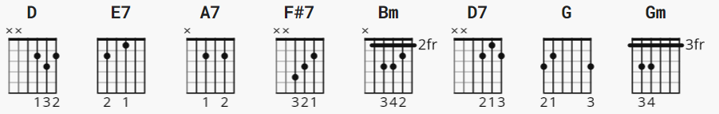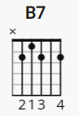

fyi: If desired, non-barre Gm can be 310033;
the 4-finger A7 sounds better in places

[verse 1]

D
Love me tender,
E7
love me sweet,
A7 D
never let me go.
D E7
You have made my life complete,
A7 D
and I love you so.

[chorus]

D F#7
Love me tender,
Bm D7
love me true,
G Gm D
all my dreams fulfilled.
B7 E7
For my darlin' I love you,
A7 D
and I always will.

[verse 2]

D
Love me tender,
E7
love me long,
A7 D
take me to your heart.
D E7
For it's there that I belong,
A7 D
and we'll never part.

[REPEAT chorus]

[verse 3]
D
Love me tender,
D7
love me dear,
A7 D
tell me you are mine.
D E7
I'll be yours through all the years,
A7 D
till the end of time.

[REPEAT chorus]
[verse 4]

D
Love me tender,
D7
love me dear,
A7 D
Darling this I know
D E7
Happiness will follow you
A7 D
Everywhere you go.

[REPEAT chorus]

