Lyin Eyes Eagles key C

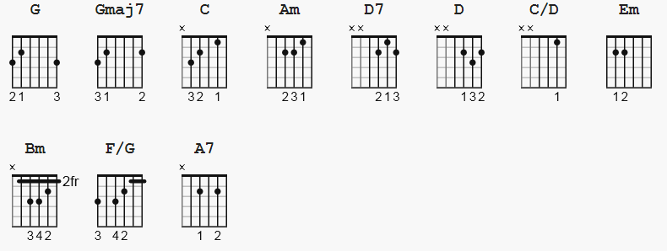 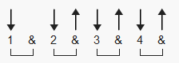 133 bpm

[Intro]
G Gmaj7 C Am D7 G

[Verse]
G Gmaj7 C
City girls just seem to find out early,
Am D7
how to open doors with just a smile.
G Gmaj7 C
A rich old man and she won't have to worry;
Am C G
she'll dress up all in lace and go in style.

G Gmaj7 C
Late at night a big old house gets lonely;
Am D7
I guess every form of refuge has its price.
G Gmaj7 C
And it breaks her heart to think her love is only
Am C G C D
Given to a man with hands as cold as ice.

G Gmaj C
So she tells him she must go out for the evening
Am D7
To comfort an old friend who's feeling down.
G Gmaj7 C
But he knows where she's goin' as she's leavin';
Am C G
She's headed for the cheatin' side of town.

[Chorus]
G C G Em Bm Am D
You can't hide your lyin' eyes, and your smile is a thin disguise.
G G7 C A7 Am D G
I thought by now you'd realize there ain't no way to hide your lying eyes.

[Interlude]
(G) Gmaj7 C Am D7 G

[Verse]
G Gmaj7 C
On the other side of town a boy is waiting
Am D7
with fiery eyes and dreams no one could steal
G Gmaj7 C
She drives on through the night, anticipating
Am C G C D
Cos he makes her feel the way she used to feel

G Gmaj7 C
She rushes to his arms, they fall together
Am D7
She whispers that it's only for a while
G Gmaj7 C
She swears that soon she'll be coming back forever
Am C G
She pulls away and leaves him with a smile

[Chorus]
G C G Em Bm Am D
You can't hide your lyin' eyes, and your smile is a thin disguise.
G G7 C A7 Am D7 G
I thought by now you'd realize there ain't no way to hide your lying eyes.

[Interlude]
(G) Gmaj7 C Am D7 G

[Verse]
G Gmaj7 C
She gets up and pours herself a strong one
Am D7
And stares out at the stars up in the sky.
G Gmaj7 C
Another night, it's gonna be a long one;
Am C G
She draws the shade and hangs her head to cry.

G Gmaj7 C
She wonders how it ever got this crazy
Am D7
She thinks about a boy she knew in school
G Gmaj7 C
Did she get tired or did she just get lazy

Am C G
She's so far gone, she feels just like a fool

G Gmaj7 C
My, oh my, you sure know how to arrange things;
Am D7
You set it up so well, so carefully.
G Gmaj7 C
Ain't it funny how your new life didn't change things;
Am C G
You're still the same old girl you used to be.

[Chorus]
G C G Em Bm Am D
You can't hide your lyin' eyes, and your smile is a thin disguise.
G G7 C A7 Am D G
I thought by now you'd realize there ain't no way to hide your lying eyes.

Gmaj7 Am D G
There ain't no way to hide your lyin' eyes
Gmaj7 Am D G
Honey, you can't hide your lyin' eyes.

[Outro]
(G) Gmaj7 Am D G

-------------

alternate [chorus] substitute C/D and F/G
[Chorus]

G C/D G Em Bm Am D
You can't hide your lyin' eyes, and your smile is a thin disguise.
G F/G C A7 Am D
I thought by now you'd realize there ain't no way to hide your lying
G
eyes.

