Maggie May Rod Stewart

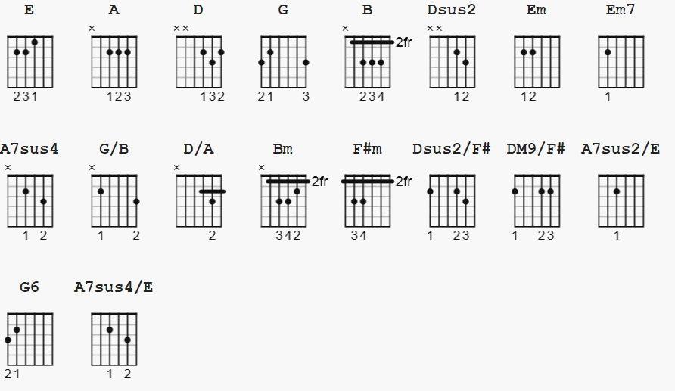
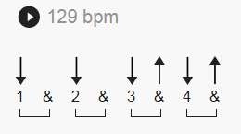 see Bateman notes last page.

Chords appear in order as played.
Not repeated if previous chord listed is used.

( from UG) E A D G B e
Intro Chords

D X X 0 2 3 2
Dsus2 x x 0 2 3 0 = Asus4, 2 fingers
Em x x 0 4 5 3
Em7 x x 0 4 3 3
G x x 0 0 3 3
A7sus4 x x 0 0 3 5
G/B 7 x 0 0 0 7
D/A x 0 0 7 7 5
G 3 5 5 0 3 3
Bm x x 4 4 3 2

Verses, Solo chords

A x 0 2 2 2 0
G 3 2 0 0 0 3
Em 0 2 2 0 0 0
F#m 2 4 4 2 2 2
Dsus2/F# 2 0 0 2 3 0
DM9/F# 2 0 0 2 2 0
A7sus2/E 0 0 2 0 0 0
Em7 0 2 2 0 3 0
G6 3 2 0 0 3 0
A7sus4/E 0 0 2 0 3 0

Outro chords

G 3 2 0 0 3 3
Maggie May

[Intro]

D Dsus2 Em Em7 G A7sus4 G/B D/A G

Dsus2 D Em Em7 G A7sus4 G/B D/A G Bm

[Verse 1]

A G D
Wake up Maggie I think I've got something to say to you
A G D
It's late September and I really should be back at school
G D G A
I know I keep you amused But I feel I'm being used
Em F#m Em Dsus2/F#
Oh Maggie I couldn’t have tried any more
Em A Em A
You led me away from home just to save you from being alone
Em |G A | D
You stole my heart, and that's what really hurts

[Verse 2]

A G D
The morning sun when it's in your face really shows your age
A G D
But that don't worry me none, in my eyes you're everything
G D G A
I laughed at all your jokes, my love you didn't need to coax
Em F#m Em Dsus2/F# DM9/F# A7sus2/E
Oh Maggie I couldn’t have tried any more
Em A Em A
You led me away from home just to save you from being alone
Em A G D
You stole my soul that's a pain I can do without

[Verse 3]

A G D
All I needed was a friend to lend a guiding hand
A G D
But you turned into a lover and mother what a lover you wore me out
G D G A
All you did was wreck my bed And in the morning kick me in the head
Em F#m Em Dsus2/F#
Oh Maggie I couldn’t have tried any more
Em A Em A
You led me away from home 'cause you didn't want to be alone
Em A G D
You stole my heart I couldn't leave you if I tried

[Guitar Solo]

| Em | A | D | G |
| Em | G-A-| D | D | try applying split bar to verses

[Verse 4]

A G D
I suppose I could collect my books and get on back to school
A G D
Or steal my daddy's cue and make a living out of playing pool
G D G A
Or find myself a rock and roll band that needs a helping hand
Em F#m Em Dsus2/F#
Oh Maggie, I wish I'd never seen your face
Em A Em A
You made a first class fool out of me, but I'm as blind as a fool can be
Em A G D
You stole my heart but I love you anyway

[Guitar Solo]

Em A D G
Em G D D
Em A D G
Em G

[Mandolin Solo]

D Em G D
D Em7 G6 D G6 D
D Em7 G6 D G6 D
D A7sus4/E G6 D G6 D
D A7sus4/E G6 D G6 D

[Outro]

D Em G D G
Maggie, I wish I’d never seen your face

D Em7 G6 D G D

Dsus2 D Em7 G6 G D G D
I’ll get on back home, one of these days

D Em7 G6 D G D
D Em7 G6 D G D

(fade out)
Lauren Bateman notes:

she uses Asus4 ( 2 fingers, in place of Dsus2/F# )
she splits a bar: | Em | G-A-| D | D | apply split bar to verses

A G D D
All I needed was a friend to lend a guiding hand
A G D D
But you turned into a lover and mother what a lover you wore me out
G D G A
All you did was wreck my bed and in the morning kick me in the head
Em F#m Em Asus4
Oh Maggie I couldn't have tried any more
Em A Em A
You lured me away from home 'cause you didn't want to be alone
Em |G - A -| D D
You stole my heart I couldn't leave you if I tried
---------------
alternate strums:

mute chop X depends on where in the verses you are
and which chords are played - sample:

D chord 1&2&3&4&
DUDU UDU then, on 2 and 4 beats, replace with hit
then extend = DUDU UDU UDU UDU = DUXU UXU UXU UXU

Em chord 1&2&3&4&
D DU UDU

https://www.youtube.com/watch?v=EYn2RmfuFYs Lauren Bateman

