Make Your Own Kind Of Music Cass Elliot key E
(Mamas and Papas )

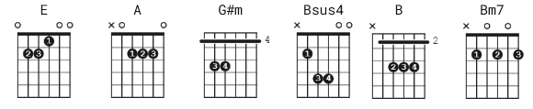 v1 of UG. note- v2 is easier
as it removes a few chords
[Intro]
E

[Verse 1]
E A
Nobody can tell ya;
E A
There's only one song worth singin'.
E A
They may try and sell ya,
G#m A Bsus4 B
'cause it hangs them up to see someone like you.

[Chorus]
E G#m A B
But you've gotta make your own kind of music
E G#m A B
Sing your own special song
E G#m A B
Make your own kind of music
E A Bsus4 B
Even if nobody else sings along

[Verse 2]
E A
You're gonna be knowin'
E A
the loneliest kind of lonely.
E A
It may be rough goin',
G#m A B
just to do your thing's the hardest thing to do.

[Chorus]
E G#m A B
But you've gotta make your own kind of music
E G#m A B
Sing your own special song
E G#m A B
Make your own kind of music
E A Bsus4 B
Even if nobody else sings along
[Bridge]
Bm7 E
So if you cannot take my hand,
Bm7 E
and if you must be goin',
B B
I will understaaaa - aaand.

[Chorus]
N.C. E G#m A B
You've gotta make your own kind of music
E G#m A B
Sing your own special song
E G#m A B
Make your own kind of music
E A Bsus4 B
Even if nobody else sings along

E G#m A B
You've gotta make your own kind of music
E G#m A B
Sing your own special song

(fade out)

