Make Your Own Kind Of Music Cass Elliot key E

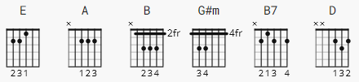

Intro: E A E A

E A
Nobody can tell ya,
E B
There's only one song worth singin'
E A
They may try and sell ay,
G#m A B
'cause it hangs them up to see somone like you.

B7
But you've gotta

E G#m A B
make your own kind of music
sing your own special song,
make your own kind of music,
A B
even if nobody else sing along.

You're gonna be knowing

the loneliest kind of lonely.

It may be rough goin',

just to do your thing's, the hardest thing to do.

B7
But you've gotta
E G#m A B
make your own kind of music
sing your own special song,
make your own kind of music,
A A
even if nobody else sing along.
D E
So if you cannot take my hand,
D
and if you must be goin',
G#m B B7
I will understand.

You've gotta make your own kind of music

sing your own special song,

make your own kind of music,

even if nobody else sing along.

You've gotta make your own kind of music

sing your own special song,

make your own kind of music,

even if nobody else sing along.

[Outro] none yet

