Mamma Mia ABBA key D

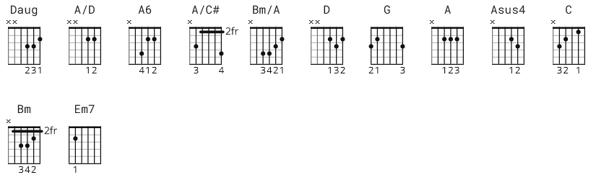
chorus: 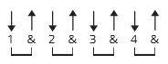 variation: 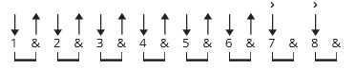
136 bpm alt strum verse: ddu-udu

Daug xx0332
A/D xx0220
A6 x02222
A/C# x4222x
Bm/A x04432

[Intro]

[Link and Outro]
D Daug D Daug

e|-----0--2--2--0--2--0-------0--2--2--0--2--0----|
B|---3------------------3---3-------------------3-|
G|-2----------------------2-----------------------|
D|------------------------------------------------|
A|------------------------------------------------|
E|------------------------------------------------|

[Intro]
D Daug D Daug

[Riff]
D Daug D Daug

[Verse 1]
D A/D D G G
I've been cheated by you since I don't know when
D A/D D G G
So I made up my mind, it must come to an end

[Pre-Chorus 1]
D Daug
Look at me now, will I ever learn?
D Daug G
I don't know how, but I suddenly lose control
G A6 A
There's a fire within my soul...
{G D} A
Just one look and I can hear a bell ring
[G D] A Asus4
One more look and I forget everything, woah-oh oh-oh

[Chorus]
D D G
Mamma mia, here I go again
[G C] G
My my,how can I resist you?
D D
Mamma mia, does it show again?
[G C] G
My my, just how much I've missed you

[Bridge]
D A/C#
Yes, I've been brokenhearted
Bm Bm/A
Blue since the day we parted
[G C] G Em7 A
Why, why did I ever let you go?
D Bm G
Mamma mia, now I really know
[G C] G Em7 A
My my, I could never let you go

[Riff]
D Daug D Daug

[Verse 2]
D A/D D G G
I've been angry and sad about things that you do
D A/D D G G
I can't count all the times that I've told you we're through

[Pre-Chorus]
D Daug
And when you go, when you slam the door
D Daug G
I think you know that you won't be away too long
G A6
You know that I'm not that strong...

[pre-chorus]

[G D] A
Just one look and I can hear a bell ring
[G D] A Asus4
One more look and I forget everything, woah-oh oh-oh

[Chorus]
D D
Mamma mia, here I go again
[G C] G
My my, how can I resist you?
D D
Mamma mia, does it show again?
[D C] G
My my, just how much I've missed you

[Bridge]
D A/C#
Yes, I've been brokenhearted
Bm F#m ( try Bm/A for F#m )
Blue since the day we parted
[G C] G Em7 A
Why, why did I ever let you go?

[Chorus]
D D G
Mamma mia, even if I say
[G C ] G
Bye bye, leave me now or never
D D
Mamma mia, it's a game we play
[G C] G
Bye bye doesn't mean forever

-----
[Chorus]
D D
Mamma mia, here I go again
[G C] G
My my, how can I resist you?
D D
Mamma mia, does it show again?
[G C] G
My my, just how much I've missed you
[Bridge]
D A/C#
Yes, I've been brokenhearted
Bm F#m or Bm/A
Blue since the day we parted
[G C] G Em7 A
Why, why did I ever let you go?

[Outro]
D Bm
Mamma mia, now I really know
[G C] G Em7 A
My my, I could never let you go...

[Outro Riff]
D Daug D Daug
D Daug D Daug

