Margaritaville Jimmy Buffett key D

chords A A7 D D7 G
strum 1 ( easy ) : D D U D D
1 2 & 3 & 4
strum 2: D Dmute U U D U
1 2 & 3 & 4 &

Intro: D Dsus2 G A D (1 strum)

[verse 1]:

D Dsus2 D Dsus2 D
Nibbling on sponge cake, watching the sun bake
A7
All of those tourists covered with oil,
Strumming my six string, on my front porch swing
D D7
Smell those shrimp, they're beginning to boil.

[chorus]:

G A D D7
Wasting away again in Marga-ritaville,
G A7 D D7
Searching for my. . . lost shaker of salt,
G A D A G
Some people claim that there's a wo-man to blame,
A7 D
But I know, it's nobody's fault.

[verse 2]:

D Dsus2 D
Don't know the rea- son that I stayed here all season,
A7
With nothing to show but this brand new tattoo,
But it's a real beauty, a Mexican cutie,
A7 A A7 A D
How it got here I haven't a clue.

[chorus]:

G A D D7
Wasting away again in Marga-ritaville,
G A D D7
Searching for my . . lost shaker of salt,
G A D A G
Some people claim that there's a wo-man to blame,
A7 D
But I know, it could be my fault

[ Instrumental Riff ]

D(3) A7 first 2 lines of verse 1
G A D A G 2nd 2 lines of chorus
A7 D

[verse 3]:

D Dsus2 D
I blew out my flip- flop Stepped on a pop top,
D A
Cut my heel, had to cruise on back home,
A A7
But there's booze in the blender And soon it will render,
A D D7
That frozen con-coction that helps me hang on.

[Play Chorus]

G A D A G
Some people claim that there's a wo-man to blame,
A7 D G A D- 1 strum
And I know, it's my own damn fault. [outro]

--------------------------------
NOTE 1:
[alternate Outro 1]

A(X5), Strum all open strings once, A(X1), D(X1)

[alternate Outro 2]

1 strum ea:
D D D Dsus2 D - G G G G* G - A A A A Asus2 A - D(hold)
G = 320003 G* = 320002 ( so move string 1 once )
Asus2 = 002200 (Fingers right, name is problematical )

NOTE 2: In several places, the 2-finger open A7 sounds better
than the 4-finger A7. particularly on the word "know".

NOTE 3: In cha cha dance, there are 2 common rhythms,
where the two are the same timing, but in different places
in a bar:

1 2 3 4&1.. and 1 2 3&4 1..
( the 1 is not necessarily the first note in the bar )

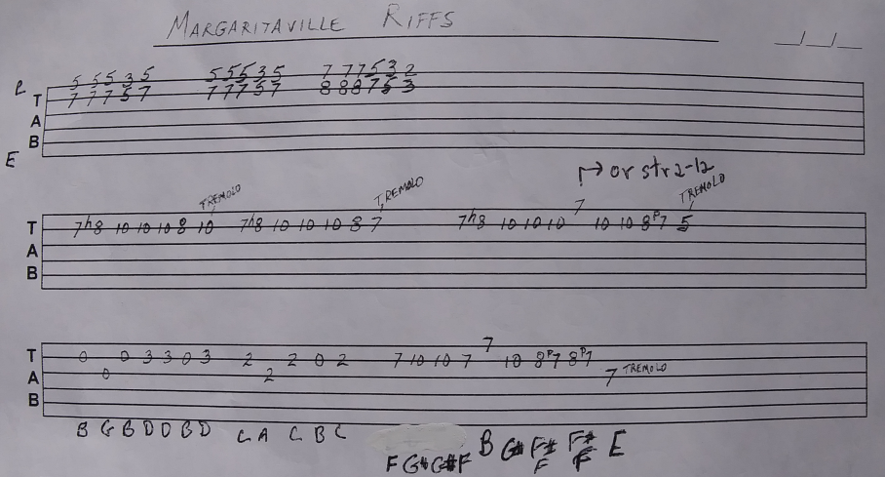

strums for rhythm or bass:

DU UD D and DUDUD Dmute and DU UD Dmute
1&2&3 4 1&2&3 4 1&2&3 4

Using the strum shown at top with no strum on 3 will
be wierd as some words demand a strum. Mix a 4 count
with D or U on 3.

