Memory Lane Old Dominion ( 2023 ) key D

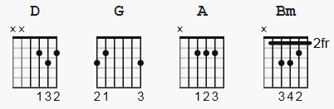 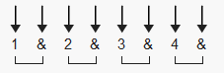 120 bpm

Capo 4th fret. = F#

[Intro]
D G

[Verse 1]
D
If I could buy a house on Memory Lane
G
I'd put my money down and I'd sign my name
D
On that little corner lot where it don't ever rain
G
And we'd stay good as new like a fresh coat of paint
D G
You'd be mine in the shine of a front porch light
D
Yeah, I might as well live there, baby
G
That's where I spend most of my time

[Chorus]
A Bm
Thinkin' 'bout those sunsets that bled into jean jacket nights
G D
Those tangled up mornings lost in paradise
A Bm
Still drunk on the feeling when I close my eyes
G
You're pulling me closer, your head on my shoulder
G
We'd never let go and we'd never be over
[Verse 2]
D
If I could buy a house on Memory Lane
G
I wouldn't have to wonder if you miss me the same
D
I'd be loving you as usual, telling you you're beautiful
G
Oh, I'd be happily delusional

[Chorus]
A Bm
Thinkin' 'bout those sunsets that bled into jean jacket nights
G D
Those tangled up mornings lost in paradise
A Bm
Still drunk on the feeling when I close my eyes
G
You're pulling me closer, your head on my shoulder
G
We'd never let go and we'd never be over

[Guitar Solo]
D G D G

[Chorus]
A Bm
Thinkin' 'bout those sunsets that bled into jean jacket nights
G D
Those tangled up mornings lost in paradise
A Bm
Still drunk on the feeling when I close my eyes
G
You're pulling me closer, your head on my shoulder
G
We'd never let go and we'd never be over

[Outro]
D
If I could buy a house on Memory Lane
G
I'd put my money down and I'd sign my name
D
On that little corner lot where it don't ever rain
G D
And baby, me and you, we'd never fade, never fade
G
We'd never fade
D G D
Never fade, never fade

