Mountain Music Alabama key G

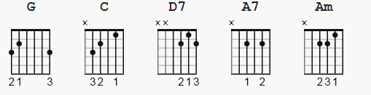 strum: B Dududu B Dududu
verse and chorus all inline 1 &a2e&a 3 &a4e&a

[Intro] ??

G C
Oh play me some mountain music

G C
Like grandma and grandpa used to play

G C
Then I'll float on down the river

D7 G
To a Cajun hideaway

C
Drift away like Tom Sawyer

G C
Ride a raft with ole Huck Finn

G
Take a nap like Rip Van Winkle

A7 D7
Day dreaming again

G C
Oh play me some mountain music

G C
Like grandma and grandpa used to play

G C
Then I'll float on down the river

D7 G
To a Cajun hideaway

G C
Swim across the river

G C
Just to prove that I'm a man

G C
Spend the day being lazy

D7
Just being nature's friend

G C
Climb a long tall hickory

G C
Bend it over skinning cats

G
Playing baseball with Chert rocks

A7 D7
Using sawmill slabs for bats

G C
Play some back home come on music

G C
That comes from the heart

G C
Play something with lots of feeling

Am D7
Cause that's where music has to start

G C
Oh play me some mountain music

G C
Like grandma and grandpa used to play

G C
Then I'll float on down the river

D7 G
To a Cajun hideaway

[Outro] TBD ??

