Mr. Tambourine Man The Byrds key G

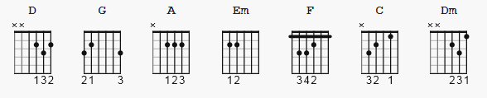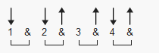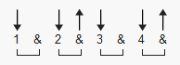
129 bpm suggested patterns 1 and 2

[Intro riff ] [ see end for another pick version]

e|---5-2-7-5-3-2-0---0---0-|
B|-3---------------3---3---|
G|-------------------------|
D|-------------------------|
A|-------------------------|
D G A 2x OR E|-------------------------| 2x

[chorus]

G A D G
Hey! Mr. Tambourine Man, play a song for me,
D G Em A A
I'm not sleepy and there ain't no place I'm going to.
G A D G
Hey! Mr. Tambourine Man, play a song for me,
D G Em A D D
In the jingle jangle morning I'll come followin' you.

[verse]

G A D G
Take me on a trip upon your magic swirlin' ship,
D G D G
My senses have been stripped, my hands can't feel to grip,
D G D G
My toes too numb to step, wait only for my boot heels
Em A A
To be wanderin'.
G A D G
I'm ready to go anywhere, I'm ready for to fade
D G D G
Into my own parade, cast your dancing spell my way,
Em A A
I promise to go under it.

[chorus]

G A D G
Hey! Mr. Tambourine Man, play a song for me,
D G Em A A
I'm not sleepy and there is no place I'm going to.
G A D G
Hey! Mr. Tambourine Man, play a song for me,
D G Em A D
In the jingle jangle morning I'll come followin' you.

[outro]

e|---5-2-7-5-3-2-0---0---0-|
B|-3---------------3---3---|
G|-------------------------|
D|-------------------------|
A|-------------------------|
E|-------------------------| . . . .

Or

D G A . . . .

OR--

e|---------------------------|------------------------------------|
B|---------------------------|-----------3------------3-----------|
G|-----2-----4---2---0-------|------0------------0----------------|
D|--0-----0--------------4---|--2------------2-------------0---2--|
A|---------------------------|------------------------------------|
E|---------------------------|------------------------------------|
1 2 + 3 + 4 + 1 + 2 + 3 + 4 +
e|---------------------------|------------------------------------|
B|---------------------------|-----------3------------3-----------|
G|-----2-----4---2---0-------|------0------------0----------------|
D|--0-----0--------------4---|--2------------2--------------------|
A|---------------------------|------------------------------------|
E|---------------------------|----------------------------2---0---|
1 2 + 3 + 4 + 1 + 2 + 3 + 4 +

* Dylan alternate:

Capo II

G = F
A = G
D = C
Em = Dm

