Mrs Brown Youve Got A Lovely Daughter Hermans Hermits

key C

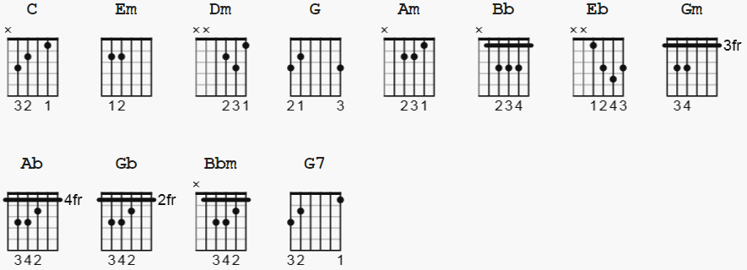

INTRO: C Em Dm G (x2)

#1.

C Em Dm G C Em Dm G
Mrs Brown you've got a lovely daughter.
C Em Dm G C Em Dm G
Girls as sharp as her are somethin' rare.
Am C Am C
But it's sad, she doesn't love me now,
Am C G
she's made it clear enough it ain't no good to pine.

#2.

C Em Dm G C Em Dm G
She wants to return those things I bought her.
C Em Dm G C Em Dm G
Tell her she can keep them just the same.
Am C Am C
Things have changed, she doesn't love me now,
Am C G Bb
she's made it clear enough it ain't no good to pine.

CHORUS:

Eb Gm Ab Bb
Walkin' about, even in a crowd, well..
Gb Bbm Bb G
you'll pick her out..makes a bloke feel, so proud.

#3.

C Em Dm G C Em Dm G
If she finds that I've been 'round to see you,
C Em Dm G C Em Dm G
tell her that I'm well and feelin' fine.
Am C Am C
Don't let on...don't say she's broke my heart.
Am C G Bb
I'd go down on my knees but it's no good to pine.

CHORUS:

Eb Gm Ab Bb
Walkin' about, even in a crowd, well..
Gb Bbm Bb G
you'll pick her out..makes a bloke feel, so proud.

#4.

C Em Dm G C Em Dm G
If she finds that I've been 'round to see you,
C Em Dm G C Em Dm G
tell her that I'm well and feelin' fine.
Am C Am C
Don't let on...don't say she's broke my heart.
Am C G G7
I'd go down on my knees but it's no good to pine.

OUTRO:

C Em Dm G C Em Dm G
Mrs Brown you've got a lovely daughter.(x4)

--------------------
one version uses F in place of Dm ; 1 3 4 5 chord sequence
but consider using Dm7 - all over or only in places ?
Baseline in places: pick bass C E D G ( strings 6,5,4)

