Mrs. Robinson Simon and Garfunkle key E7

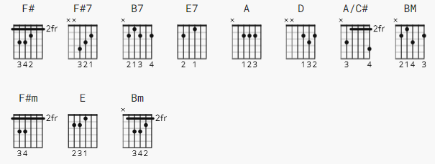 no capo

[Intro Pattern]
E|----------------|
B|----------------|
G|----------------|
D|-------2-4------|
A|---2-4----------|
E|-2--------------|

[Intro]

F# F#7
Di di di di di di di di di di di
B7
Doo doo doo doo doo doo doo doo doo
E7 A D A/C# BM F#7
Di di di di di di di di di di di di

[Chorus]

E7 A F#m
And here's to you Mrs Robinson
A F#m D E
Jesus loves you more than you will know (wo wo wo)
A F#m
God bless you please Mrs Robinson
A F#m D
Heaven holds a place for those who pray
Bm F#
(hey hey hey...hey hey hey)

[Verse 1]
F#7
We'd like to know a little bit about you for our files
B7
We'd like to help you learn to help yourself
E7 A D A/C# Bm
Look around you, all you see are sympathetic eyes
F#7 E7
Stroll around the grounds until you feel at home
[Chorus]

E7 A F#m
And here's to you Mrs Robinson
A F#m D E
Jesus loves you more than you will know (wo wo wo)
A F#m
God bless you please Mrs Robinson
A F#m D
Heaven holds a place for those who pray
Bm F#
(hey hey hey...hey hey hey)

[Verse 2 ]
F#7
Hide it in a hiding place where no one ever goes
B7
Put it in your pantry with your cupcakes
E7 A D A/C# Bm
It's a little secret just the Robinson's affair
F# F# E7
Most of all, you've got to hide it from the kids

[Chorus]

E7 A F#m
Coo coo ca-choo, Mrs Robinson
A F#m D E
Jesus loves you more than you will know (wo wo wo)
A F#m
God bless you please Mrs Robinson
A F#m D
Heaven holds a place for those who pray
Bm F#
(hey hey hey...hey hey hey)

[Verse 3]
F#7
Sitting on a sofa on a Sunday afternoon
B7
Going to the candidates' debate
E7 A
Laugh about it, shout about it
D A/C# Bm
When you've got to choose
F#7 E7
Every way you look at it, you lose
[Chorus]

E7 A F#m
Where have you gone Joe Dimaggio?
A F#m D E
A nation turns its lonely eyes to you (woo woo woo)
A F#m
What's that you say Mrs Robinson?
A F#m D
Joltin' Joe has left and gone away
Bm F#
(hey hey hey...hey hey hey)

[Outro]
F# |F# |F# |F# ||

