Na Na Hey Hey Kiss Him Goodbye steam or Dave Clark Boys

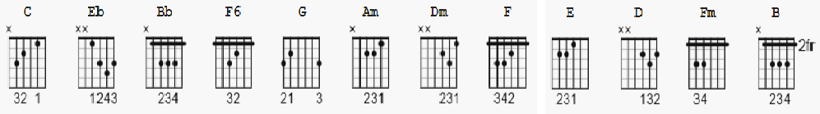

[Intro]

C Eb Bb C

C C Eb Bb C
Na na na na, na na, hey hey-ey, goodbye

[Verse]

C F6 G C F6 G
He'll never love you, the way that I love you
He's never near you to comfort and cheer you
C Am Dm G
'Cause if he did, no no, he wouldn't make you cry
When all those sad tears are fallin' baby from your eyes
F E Am D
He might be thrillin' baby but a-my love (my love, my love)
He might be thrillin' baby but a-my love (my love, my love)
C F Fm
So kiss him (I wanna see you kiss him. Wanna see you kiss him)
So kiss him (I wanna see you kiss him. I wanna see you kiss him)
C
Go on and kiss him goodbye, now
Go on and kiss him goodbye,

[Chorus]

Eb Bb C
Na na na na, hey hey-ey, goodbye
C Eb Bb C
Na na na na, na na, hey hey-ey, goodbye

[Coda]

Eb Bb C
Na na na na, hey hey-ey, goodbye
C Eb B C (fade out)
Na na na na, na na, hey hey-ey, goodbye

