Needles and Pins The Searchers (Jackie DeShannon) key A

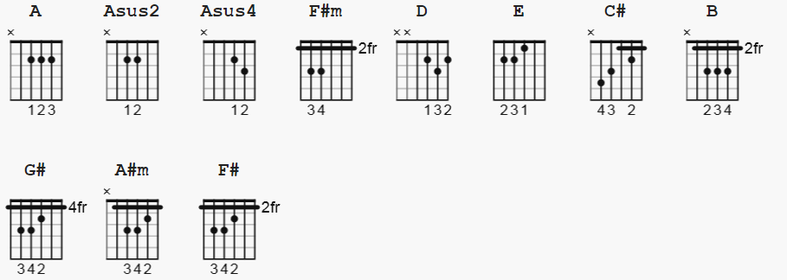

strum: one can be Old Faithful

A A Asus2 A Asus2 Asus4 A Asus2 A 2x
1 & 2 & a 3 & 4 & one can play part as triplet time
A
I saw her today, I saw her face
F#m
It was a face I loved and I knew
A F#m
I had to run away and get down on my knees and pray

That they'd go away
A A Asus2 A Asus2 Asus4 A Asus2 A
But still they begin
F#m
Needles and pins
D
Because of all my pride
E
The tears I gotta hide

A
Hey, I thought I was smart, I won her heart
F#m
Didn't think I'd do it, but now I see
A
She's worse to him than me
F#m
Let her go ahead, take his love instead

And one day she will see
A A Asus2 A Asus2 Asus4 A Asus2 A
Just how to say please
F#m
And get down on her knees
D
Yeah, that's how it begins

E
She'll feel those needles and pins

A-hurtin her, a-hurtin her

C# B
Why can't I stop and tell myself I'm wrong, I'm wrong, so wrong
A G#
Why can't I stand up and tell myself I'm strong

C#
Because I saw her today, I saw her face
A#m
It was a face I loved and I knew
C# A#m
I had to run away and get down on my knees and pray

That they'd go away
C#
But still they begin
A#m
Needles and pins

F#
Because of all my pride
G#
The tears I gotta hide

C#
Ah, needles and pins

Needles and pins

Needles and pins

