No Matter What Badfinger Key A

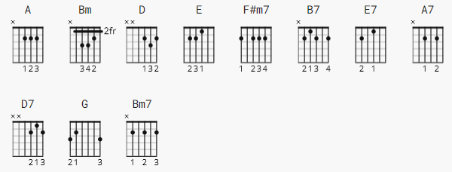

Strum TBD

[Intro]

A A A A N.C.

[Verse 1]
A Bm
No matter what you are, I will always be with you
D E D E A E N.C.
Doesn't matter what you do girl, ooh girl with you

[Verse 2]
A Bm
No matter what you do, I will always be around

D E D E A
Won't you tell me what you found girl, ooh girl, want you
(arpeggiated A chord fill)

[Chorus]

F#m7 B7 E7 A7
Knock down the old gray wall, be a part of it all
D7 Bm A
Nothing to say, nothing to see, nothing to do
F#m7 B7 E7 A7
If you would give me all, as I would give it to you
D7 Bm G E N.C.
Nothing would be, nothing would be, nothing would be
GGGGGGG, E (stop)

[Verse 3]
A Bm
No matter where you go, there will always be a place
D E D E A
Can't you see it in my face girl, ooh girl, want you
(arpeggiated A chord fill)
[Solo]

A A Bm Bm
D E D E A A OR the following:

G|--/9--\6--\4--\2----/9--\6--\4--\2----/11--\7--\6--\4---/11--\7--\6--\4---|
G|---/7--/9--/7--/9--\2--14-------------------------------------------------|

[Chorus]

F#m7 B7 E7 A7
Knock down the old gray wall, be a part of it all
D7 Bm A
Nothing to say, nothing to see, nothing to do
(arpeggiated A chord fill)

F#m7 B7 E7 A7
If you would give me all, as I would give it to you
D7 Bm G E N.C.
Nothing would be, nothing would be, nothing would be
GGGGGGG, E (stop)

[Verse 4]
A Bm7
No matter what you are, I will always be with you
D E D E A N.C.
Doesn't matter what you do girl, ooh girl with you
(arpeggiated A chord fill))stop

[Outro]

D E D E A
Ooh girl, you girl, want you (fill)

D E D E A A
Ooh girl, you girl, want you or (fill)

fill

e|--0----------0-------------------------|
B|-2-2-3-5-3-2---------------------------|
G|--------------4-2----------------------|
D|---------------------------------------|
A|---------------------------------------|
E|---------------------------------------|

